COUNCIL ASSESSMENT REPORT

Panel Reference | PPSSEC-20
DA Number | DA.2019.091
LGA | Burwood
Proposed Development | Demolition of the existing structures and the construction of a 30 level mixed use development containing 179 residential units above basement parking
Street Address | 28-34 Victoria Street, Burwood
Applicant/Owner | Applicant: Urban Link Pty Ltd  Owner: VSD Investments Pty Ltd
Date of DA lodgement | 27 September 2019
Number of Submissions | 9
Recommendation | Approved Subject to Conditions
Regional Development Criteria (Schedule 7 of SEPP (State and Regional Development) 2011) | General Development over $30M
List of all relevant 4.15(1)(a) matters | - Sydney Regional Environmental Plan (Sydney Harbour Catchment) 2005  - State Environmental Planning Policy (Vegetation In Non-Rural Areas) 2017  - State Environmental Planning Policy (State and Regional Development) 2011  - State Environmental Planning Policy No. 55 – Remediation of Land  - State Environmental Planning Policy (Infrastructure) 2007  - State Environmental Planning Policy (Building Sustainability Index: BASIX) 2004  - State Environmental Planning Policy (Vegetation in Non-Rural Areas) 2017  - State Environmental Planning Policy No. 65 – Design Quality of Residential Apartment Development  - Burwood Local Environmental Plan (BLEP) 2012  - Burwood Development Control Plan (BDCP) 2013  - The likely social, environmental and economic impacts of the development  - The suitability of the site for the development  - The Public Interest  - Submissions made under the Act and Regulations
List all documents submitted with this report for the Panel’s consideration | - Architectural Plan No’s: DA-001 D; DA-102D; DA-103D; DA-104D; DA-105D; DA-106D; DA-107D; DA-108D; DA-109D; DA-110D; DA-111D; DA-112D; DA-113D; DA-114D; DA-115D; DA-116D; DA-117D; DA-118D; DA-119D; DA-120D; DA-121D; DA-122D; DA-123D; DA-124D; DA-125D; DA-126D; DA-127D; DA-128D DA-134D; DA-135D; DA-136D DA-201D; DA-202D; DA-203D; DA-204D; DA-205D DA-301 D; DA-302 D; DA-303 D; DA-304 D DA-1401D; DA-1402D; DA-1403D; DA-1404D; DA-1405D; DA-1406D; DA-1407D; DA-1408D prepared by Urbanlink dated 12 August 2020;  - Survey Plan No. 12076-6 prepared by Geometra Consulting dated 21 April 2017;  - Landscape DA Report, Issue C, prepared by Tuft Design Studio dated 28 July 2020;  - Statement of Environmental Effects & Clause 4.6 Submissions, prepared by City Plan dated September 2019;  - BASIX Certificate No. 1039439M, prepared by Greenworld Architectural Drafting dated 17 September 2019;  - Heritage Impact Statement prepared by Weir Phillips Heritage and Planning dated August 2019;  - Traffic, Parking & RMS Matters prepared by Varga Traffic Planning Pty Ltd dated 8 April 2020;  - Aboricultural Impact Assessment prepared by TALC dated 16 August 2019.
Report prepared by | Planning Ingenuity (Consultant Town Planner)
Report date | 8 September 2020
Summary of s4.15 matters  Have all recommendations in relation to relevant s4.15 matters been summarised in the Executive Summary of the assessment report? |  | Yes
Legislative clauses requiring consent authority satisfaction  Have relevant clauses in all applicable environmental planning instruments where the consent authority must be satisfied about a particular matter been listed, and relevant recommendations summarized, in the Executive Summary of the assessment report?  e.g. Clause 7 of SEPP 55 - Remediation of Land, Clause 4.6(4) of the relevant LEP |  | Yes
Clause 4.6 Exceptions to development standards  If a written request for a contravention to a development standard (clause 4.6 of the LEP) has been received, has it been attached to the assessment report? |  | Not Applicable
Special Infrastructure Contributions  Does the DA require Special Infrastructure Contributions conditions (S94EF)?  Note: Certain DAs in the Western Sydney Growth Areas Special Contributions Area may require specific Special Infrastructure Contributions (SIC) conditions |  | No
Conditions  Have draft conditions been provided to the applicant for comment?  Note: in order to reduce delays in determinations, the Panel prefer that draft conditions, notwithstanding Council’s recommendation, be provided to the applicant to enable any comments to be considered as part of the assessment report |  | Yes

(PPSSEC-20) DA.2019.091 – 28-34 Victoria Street, Burwood – Demolition of the existing structures and the construction of a 30 level mixed use development containing 179 residential units above basement parking.

REPORT BY: Planning Ingenuity (Consultant Planner)

Owner: VSD Investments Pty Ltd
Applicant: Urban Link Pty Ltd
Location: 28-34 Victoria Street, Burwood
Zoning: B4 Mixed Use

Proposal
The application proposes the demolition of the existing structures and the construction of a 30 level mixed use development containing 179 residential units above basement parking.

Regional Planning Panel Referral Criteria
The application is referred to the Regional Planning Panel as the proposal has a capital investment value over $30 million.

Locality
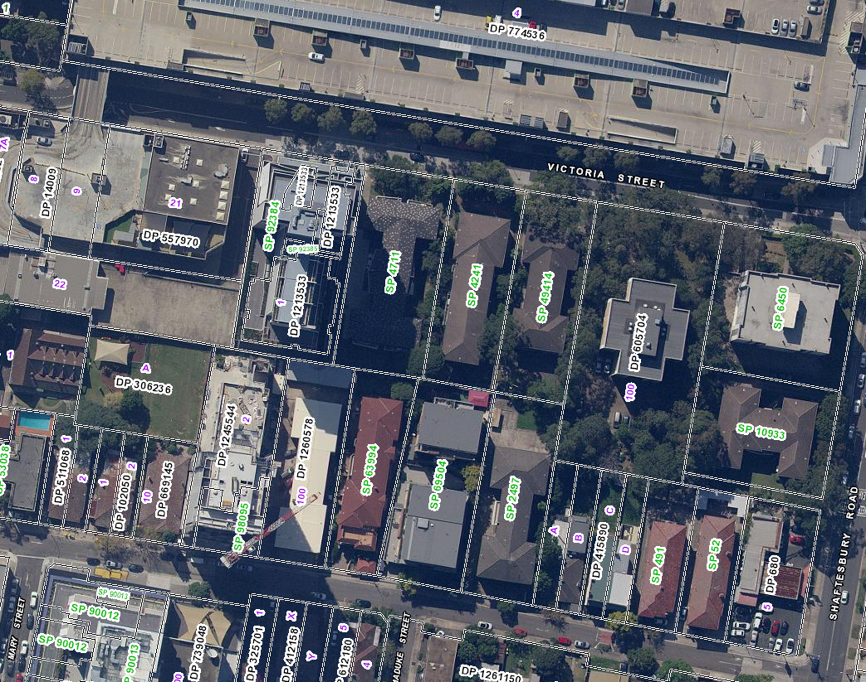

Figure 1: Aerial image of 28-34 Victoria Street, Burwood (Source: Six Maps).

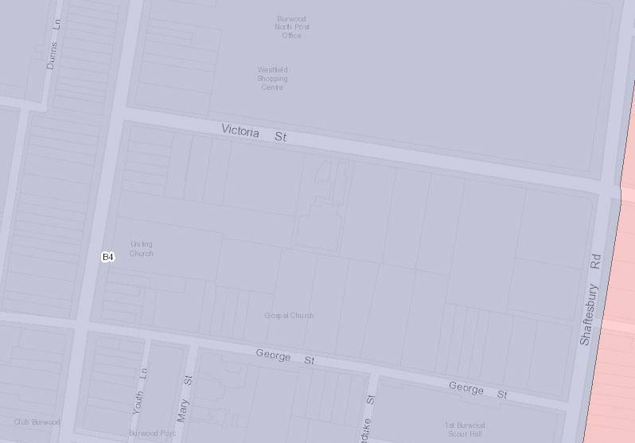

Figure 2: Cadastral/Zoning Map of 28-34 Victoria Street, Burwood (Source: Planning Portal).

Subject Site
The subject site is known as 28-34 Victoria Street, Burwood and comprises of three adjoining lots that are legally described as SP 49414, SP 4241, and SP 4711. The site is located on the southern side of Victoria Street within Burwood Town Centre.

The site is generally rectangular shaped with a 70.235m frontage to Victoria Street, a length of 60.635m on the western side boundary, a length of 61.145m on the eastern side boundary, a rear boundary length of 69.73m and a total site area of 4,240.6m².

The site slopes down towards Victoria Street, with a cross fall of approximately 2.7m from the southeast corner to the northwest corner. There are a total of 33 trees located on or directly adjacent to the site. These are primarily located within the front, rear and side setback areas of existing buildings. One (1) Chinese Elm tree (“T16”) is a street tree, located in front of No. 28 Victoria Street. A further street tree is located in front of No. 30 Victoria Street but has not been identified on the submitted Survey Plan or tree schedule within the accompanying Arboricultural Impact Assessment.

Situated on the site are three existing free standing residential flat buildings with at-grade and undercroft car parking. The three existing buildings on site comprise the following:

- No. 28 Victoria Street - a part 2, part 3 storey brick built residential flat building with parking located at ground level underneath the rear section and at-grade within the rear setback area. Vehicular access is provided via a concrete driveway along the eastern side, accessed from Victoria Street.
- No. 28A-30 Victoria Street - a 4 storey brick built residential flat building with garages and parking located at ground level underneath and access provided via a concrete driveway along the eastern side, accessed from Victoria Street.
- No. 32-34 Victoria Street - - a 4 storey brick built residential flat building with parking located and access provided via a concrete driveway along the western side, accessed from Victoria Street.

Images of the existing buildings are provided below (see Images 1, 2 and 3 below)

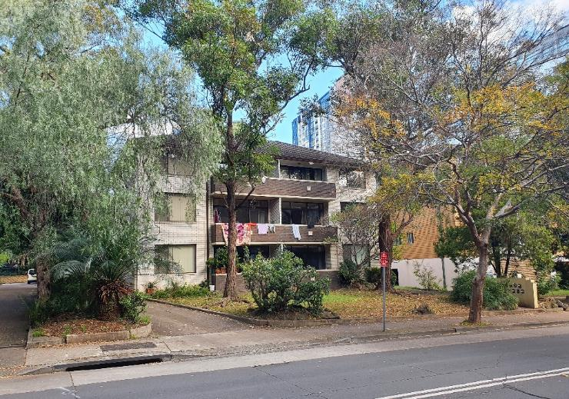
Image 1: No. 28 Victoria Street, Burwood
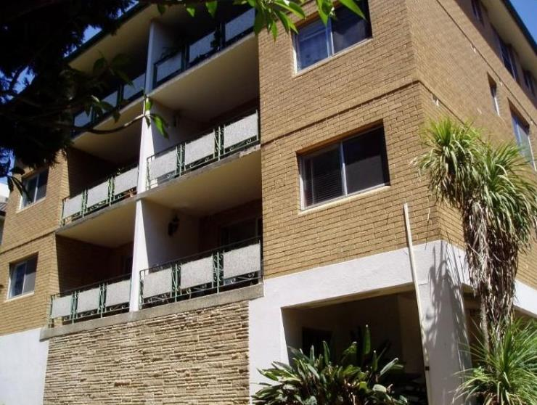
Image 2: Nos. 28A - 30 Victoria Street, Burwood

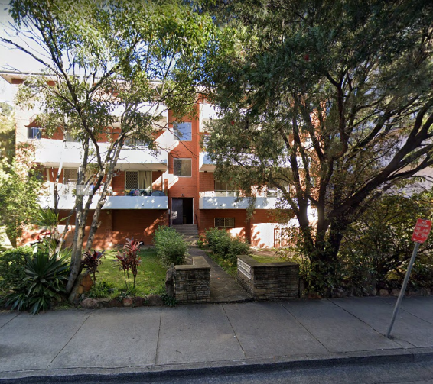
Image 3: Nos. 32 - 34 Victoria Street, Burwood

Surrounding Development
Surrounding development is a mixture of commercial, residential and mixed use development, characteristic of the sites location within Burwood Town Centre.

Adjoining the site to the west is an existing multi storey concrete high rise mixed use building known as “Victoria Towers” at No. 36-38 Victoria Street. The development was originally approved by JRPP on 1 February 2012 (DA.2012.012) and most recently modified on 1 September 2015. The building ranges from 13 to 18 storeys in height and contains commercial uses at ground level fronting Victoria Street with residential and serviced apartments above and to the rear. Parking and services are located over 4 basement levels, with access provided from Victoria Street (see Image 4 below).

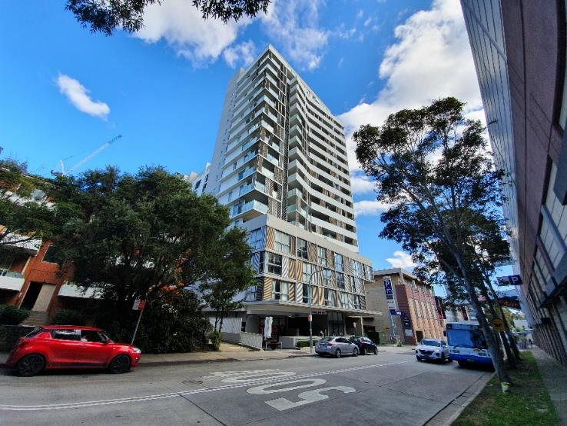
Image 4: No. 36-38 Victoria Street (background) with No. 32-34 Victoria Street in the foreground

Adjoining the site to the east is an eight storey brick residential flat building with at-grade car parking known as No. 24-26 Victoria Street (Image 5 below). The property contains mature tree planting along within the front and western side setback areas.

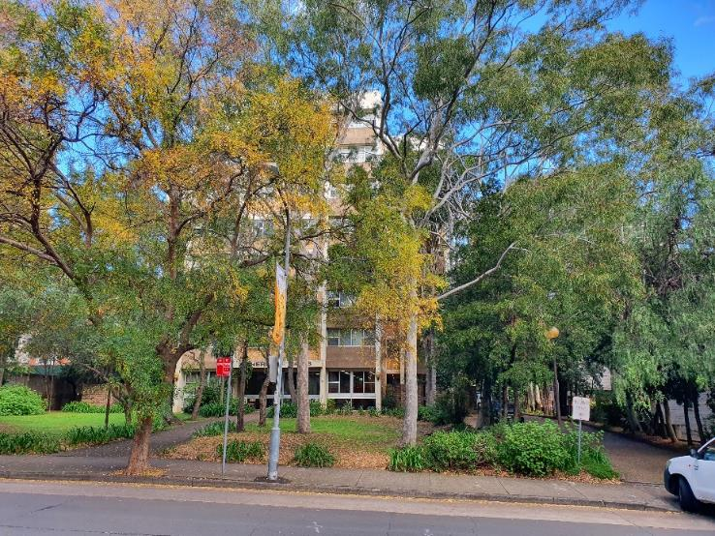
Image 5: No. 24-26 Victoria Street, Burwood
Further to the east is No. 18-22 Victoria Street, a 9 storey residential flat building located on a corner lot on the intersection of Victoria Street and Shaftesbury Road (see Image 6 below).
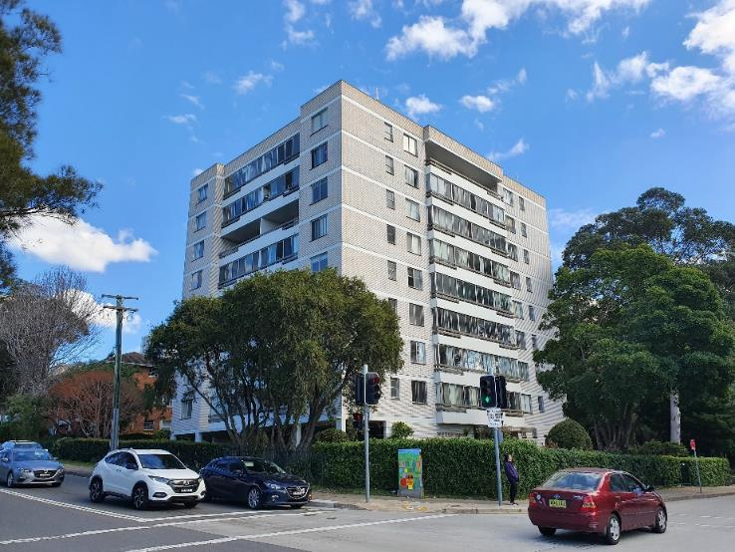
Image 6: No. 18-22 Victoria Street, Burwood
Opposite the site, on the northern side of Victoria Street is Westfield Burwood Shopping Centre at No. 98A-114 Burwood Road. The building is approximately 3 to 4 storeys high with extensive basement car parking beneath (see Image 7 below).

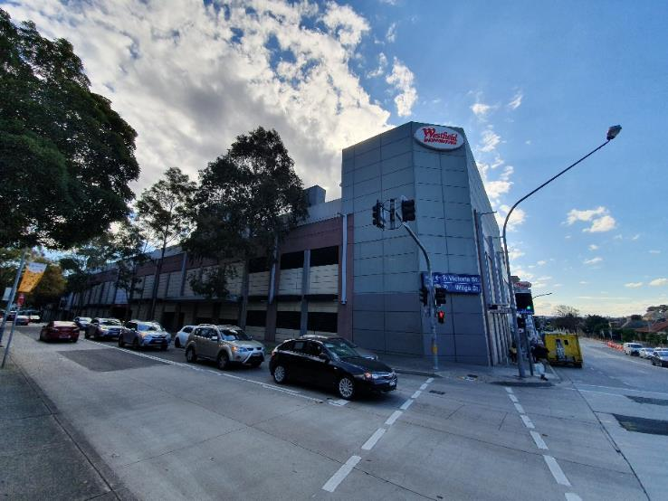
Image 7: Westfield Burwood, viewed from the intersection of Victoria Street and Shaftsbury Road

Adjoining the site to the south are a number of properties with frontages to George Street. This includes No. 17 George Street, a 3 storey residential flat building, No. 19 George Street, a 5 storey residential flat building, and No. 21 George Street, a 3 storey residential flat building. No. 23-27 George Street contains a vacant lot, formerly occupied by a 3 storey residential flat building (Images 8, 9 & 10 below). No. 23-27 George Street benefits from development consent (DA.2016.179) for a 20 storey mixed used development over basement parking, which was most recently modified on 30 May 2019 (DA.2016.179.2).

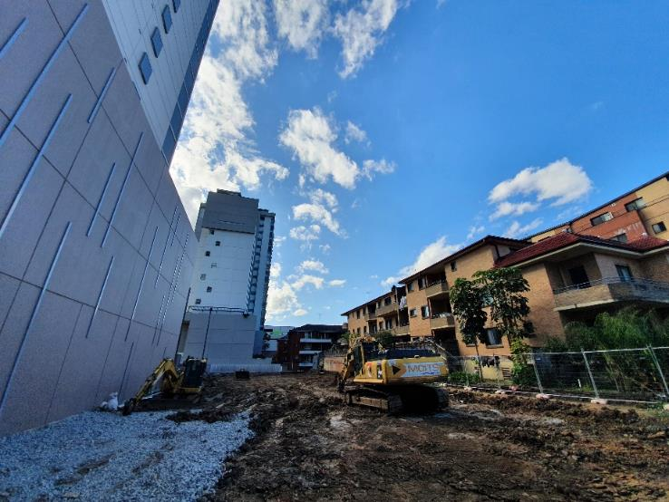
Image 8: View across the vacant lot at No. 23-27 George Street with the subject site in the background

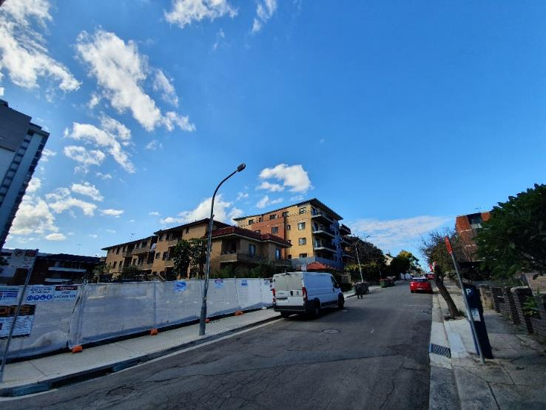
Image 9: Nos. 23-27 (foreground), 21 (centre), and 19 (background) George Street

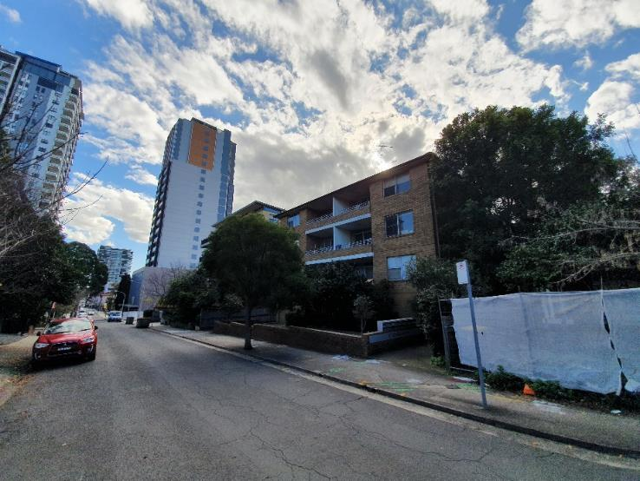
Image 10: No. 17 George Street, Burwood

Adjoining No. 17 George Street to the east are a pair of single storey semi-detached dwellings at Nos. 13 and 15 George Street (see Image 11 below). No. 9 & 11 George Street adjoins those to the east and comprises of a two storey pair of Victorian semi-detached houses which are local heritage items (Item No. I56). Nos. 9-15 George Street has been approved on 13 February 2018 (DA.2016.98) for redevelopment for an 18 storey mixed use building over basement parking. The heritage listed buildings will be integrated into the design of the approved development.

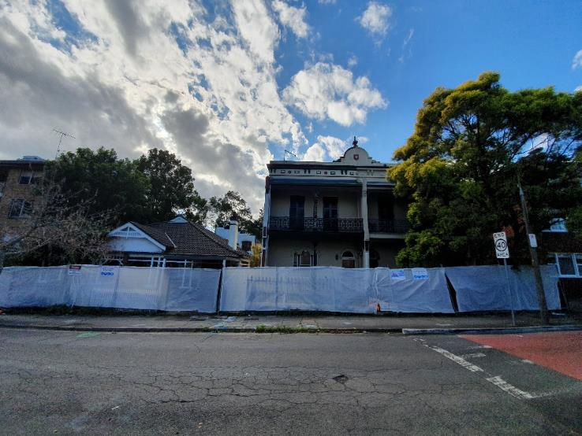
Image 11: Nos. 13 and 15 (left), and 9 & 11 (right) George Street

Given the location of the site within the Burwood Town Centre precinct, there are a large number of new high rise developments that have recently been completed or are currently under construction. The surrounding skyline is therefore evolving, with many of the new developments within close proximity of the site (see Image 12 below).

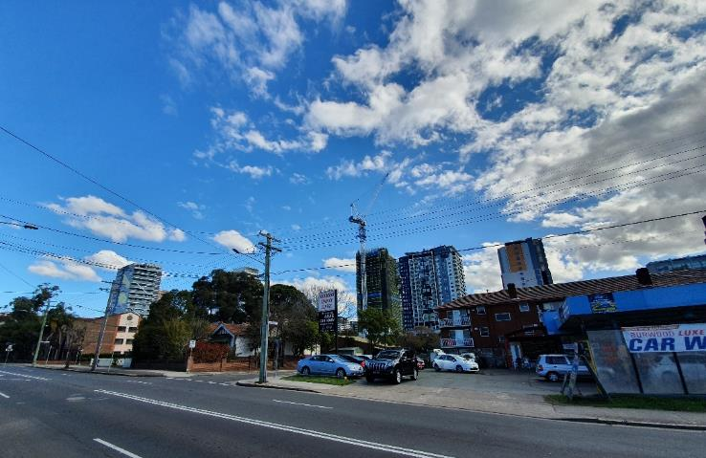
Image 12: Burwood Town Centre skyline viewed westwards from Shaftesbury Road with new tower developments in the background

Burwood Road located approximately 140m due west of the site comprises of a high street containing a number of shops and businesses. Buildings along Burwood Road are generally two or three storeys in height. A number of local heritage items are located along Burwood Road, including “Ely House” at No. 122-126 Burwood Road (see Image 13 below).

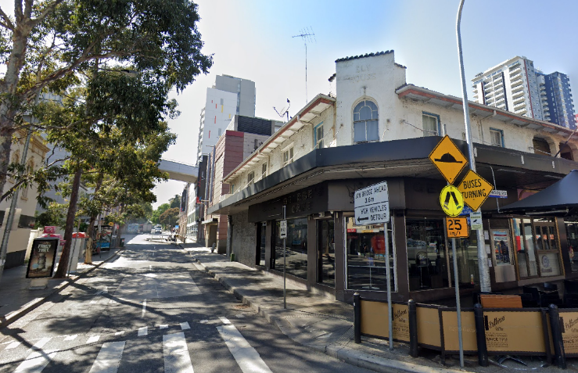
Image 13: View eastwards towards the site from Burwood Road with “Ely House” in the foreground

Development on the eastern side of Shaftesbury Road falls outside of Burwood Town Centre precinct and comprises of low density residential housing.

DESCRIPTION OF DEVELOPMENT
The proposed amended development seeks consent for the demolition of the existing structures and the construction of a 30 level mixed use development comprising of a 3 storey podium and 27 storey residential tower, containing 6,296sq.m of non-residential floor space and 179 residential units over 4 levels of basement parking with 330 car parking spaces and associated landscaping.

The specifics of the proposal are as follows:

- Basement Car Park Level 4
Contains 68 residential car spaces, 92 residential storage cages, lift access and fire stair access.

- Basement Car Park Level 3
Contains 92 residential car spaces (including 1 car wash bay), 83 residential storage cages, lift access and fire stair access.

- Basement Car Park Level 2
Contains 69 residential car spaces (including 1 car wash bay, 36 visitor spaces and 18 accessible spaces), 12 residential motorcycle spaces, 46 residential bicycle spaces, 4 residential storage cages, a turning bay, 3 bulky storage areas, lift access and fire stair access.

- Basement Car Park Level 1
Contains 51 retail car spaces (including 1 accessible space), 26 restaurant/café car spaces (including 1 accessible space), 10 commercial car spaces (including 1 accessible space), 4 non-residential motorcycle spaces, 12 non-residential bicycle parking spaces, storage cages, residential waste room and residential lift lobby, non-residential goods lift, non-residential lift access, travellators and fire stair access.

- Ground Floor Level
Residential and non-residential lobby areas including lift access, vehicular entrance (from Victoria Street), loading bay, non-residential and residential waste collection areas, bathroom facilities, 9 non-residential tenancies including 4 retail tenancies (56-124sq.m in area), 2 café tenancies (71-75sq.m in area), and 3 restaurant tenancies (137-240sq.m in area), substation, travellators, goods lift and fire stairs.

- Level 1
Non-residential lobby, 2 restaurant/retail tenancies (220 and 453sq.m in area) and associated outdoor terrace areas, and two retail tenancies (334sq.m and 1,076sq.m), bathroom facilities, travellator and lift access, goods lift and fire stairs.

- Level 2
Non-residential lobby, 1 office/commercial tenancy (1,487sq.m) and associated outdoor terraces, 2 retail tenancies (165sq.m and 416sq.m), bathroom facilities, lift access and fire stairs.

- Level 3
3 x 1 bedroom, 4 x 2 bedroom, 1 x 3 bedroom units, 3 residential communal open space areas (155, 220, and 977sq.m), lift access and fire stairs.

- Levels 4-20
2 x 1 bedroom, 5 x 2 bedroom, 1 x 3 bedroom units, lift access and fire stairs.

- Level 21
2 x 1 bedroom, 3 x 2 bedroom, 1 x 3 bedroom units, communal open space area (214sq.m), lift access and fire stairs.

- Level 22
2 x 1 bedroom, 3 x 2 bedroom, 1 x 3 bedroom units, lift access and fire stairs.

- Level 23
1 x 1 bedroom, 2 x 2 bedroom, 1 x 3 bedroom units, communal open space (209sq.m), lift access and fire stairs.

- Levels 24-27
1 x 1 bedroom, 2 x 2 bedroom, 1 x 3 bedroom units, lift access and fire stairs.

- Levels 28 & 29
1 x 2 bedroom, 2 x 3 bedroom split level penthouse units, lift access and fire stairs.

- Roof Level
Services and solar PV array.

Proposed Apartment Mix
A mixture of 1, 2, and 3 bedrooms are proposed as follows:

- 46 (26%) x 1 bedroom apartments;
- 106 (59%) x 2 bedroom apartments; and
- 27 (15%) x 3 bedroom apartments.

SITE HISTORY
There is no development application or pre-development application history relevant to the subject application.

APPLICATION HISTORY

- Development Application was lodged with Council on 27 September 2019;
- The application was referred to the following internal Council departments and external referrals on 21 March 2019:
  - Development Engineer;
  - Environmental Health;
  - Traffic Engineer;
  - Heritage Advisor;
  - Tree Management Officer; and
  - Transport for NSW (formerly RMS).
- The application underwent public exhibition for 21 days from 16 October 2019 until 8 November 2019;
- The application was referred to GMU Urban Design & Architects to undertake a peer review of the proposed development;
- Additional information letter sent to applicant on 18 February 2020 raising the following matters;
  - Urban design review comments;
  - Heritage assessment comments;
  - Tree management comments;
  - Strategic Planning comments regarding community infrastructure;
  - Traffic and parking comments;
  - TfNSW (RMS) comments;
  - Stormwater drainage design comments;
  - Request for a Wind Report; and
  - Summary of submissions received to date.
- On 16 April 2020, amended plans and documentation were submitted to Council;
- The amended plans were re-referred to GMU and internal Council departments for further review;
- On 21 May 2020 comments were received from GMU relating to the amended plans;
- On 25 May 2020, further geotechnical clarification was sought regarding groundwater levels and revised additional basement level;
- Amended plans were renotified to the public between 29 May 2020 and 15 June 2020;
- On 3 June 2020, an updated Geotechnical Report was submitted to Council;
- On 14 July 2020 a further request for additional information was emailed to the applicant, raising the following matters for clarification:
  - Building Height Plane;
  - Landscaping;
  - Car parking numbers; and
  - Insufficient/incorrect information submitted.
- On 22 July 2020 and 12 August 2020, amended plans and documentation were submitted to Council. These plans form the basis for this report.

STATUTORY PLANNING FRAMEWORK
The application is assessed under the provisions of Section 4.15 of the Environmental Planning and Assessment Act 1979, as amended, which include:

- Sydney Regional Environmental Plan (Sydney Harbour Catchment) 2005
- State Environmental Planning Policy (Vegetation In Non-Rural Areas) 2017
- State Environmental Planning Policy (State and Regional Development) 2011
- State Environmental Planning Policy No. 55 – Remediation of Land
- State Environmental Planning Policy (Infrastructure) 2007
- State Environmental Planning Policy No. 65 – Design Quality of Residential Apartment Development
- State Environmental Planning Policy (Building Sustainability Index: BASIX) 2004
- Burwood Local Environmental Plan (LEP) 2012
- Burwood Development Control Plan (DCP) 2013
- The likely social, environmental and economic impacts of the development
- The suitability of the site for the development
- The Public Interest
- Submissions made under the Act and Regulations

These matters are considered in this report.

Sydney Regional Environmental Plan (Sydney Harbour Catchment) 2005
The site is located within the designated hydrological catchment of Sydney Harbour and is subject to the provisions of the above SREP.

The Sydney Harbour Catchment Planning Principles must be considered in the carrying out of development within the catchment.

The site is within the Sydney Harbour Catchment and eventually drains into the Harbour. However, the site is not located in the Foreshores Waterways Area or adjacent to a waterway and therefore, with the exception of the objective of improved water quality, the objectives of the SREP are not applicable to the proposed development. The development is consistent with the controls contained with the deemed SEPP.

State Environmental Planning Policy (Vegetation in Non-Rural Areas) 2017
The State Environmental Planning Policy (Vegetation in Non-Rural Areas) 2017 (Vegetation SEPP) commenced on 25 August 2017. The Vegetation SEPP works together with the Biodiversity Conservation Act 2016 and the Local Land Services Amendment Act 2016 to create a framework for the regulation of clearing of native vegetation in NSW.

A total of 33 trees are located on or directly adjacent to the site. This includes 23 trees located on the site, 8 trees directly adjacent to the site (within the curtilage of No. 26), and two (2) street trees located on Victoria Street. It is noted that the submitted Survey Plan and Arboricultural Impact Assessment only identify one (1) street tree, being a Chines Elm (“T16”) located in front of No. 28 Victoria Street. There is an additional street tree located in front of No. 30 Victoria Street.

Under the amended plans, 24 trees are proposed to be removed as part of the development. This includes all 23 trees located on the site, as well as T16, the Chinese Elm street tree located in front of No. 28. Eight (8) trees located on the eastern side of the site, within the curtilage of No. 26 are proposed to be retained and protected, which has been assisted by the inclusion of a 3m wide deep soil zone along the eastern side of the site. The application does not outline what is proposed for the unidentified street tree in front of No. 30, however given the setback of the development from this tree it is reasonable to assume that it can be retained.

The proposed landscaping scheme is considered to be consistent with the objectives of the SEPP. Council’s Tree Management Officer has reviewed the amended plans including the Landscape Scheme prepared by TURF and the Arboricultural Report prepared by TALC and has raised no objection to the proposed tree removals, subject to recommended conditions including a contribution towards replacement street tree planting to mitigate the removal of T16. Conditions of consent will also require the protection of trees along the eastern side of the site, within the curtilage of No. 26 Victoria Street, as well as the unidentified street tree in front of No. 30 Victoria Street.

Given the above, the proposal is considered to satisfy the provisions of the Vegetation SEPP.

State Environmental Planning Policy No 55 – Remediation of Contaminated Land
This Policy provides a framework for the assessment, management and remediation of contaminated land. Clause 7(1) of the Policy prevents Council from consenting to development unless:
- It has considered whether the land is contaminated, and
- If the land is contaminated, it is satisfied that the land is suitable in its contaminated state (or will be suitable, after remediation) for the purpose for which the development is proposed to be carried out, and
- If the land requires remediation to be made suitable for the purpose for which the development is proposed to be carried out, it is satisfied that the land will be remediated before the land is used for that purpose.

The site is not identified by Council or any other authority as being subject to or potentially subject to contamination. A Targeted Site Soil Assessment prepared by FIMA accompanies the application and concludes that the site is not a contamination risk for soil exposure and is suitable for residential use.

Furthermore, it is noted that the site has a long history of residential land use which is demonstrated by the below satellite imagery from 1943 to present below (Figures 3 & 4 below). In this regard, further investigation is not considered to be warranted.

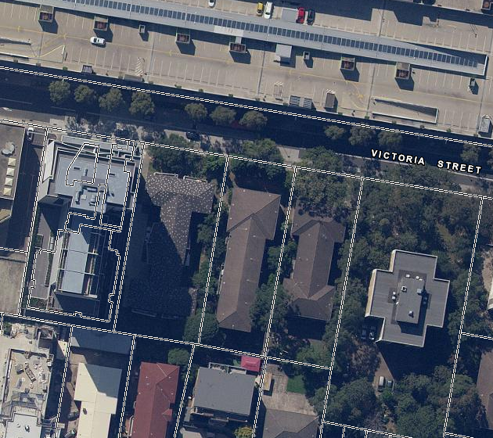
Figure 3: Present Day Aerial image of 28-34 Victoria Street, Burwood (Source: Six Maps).

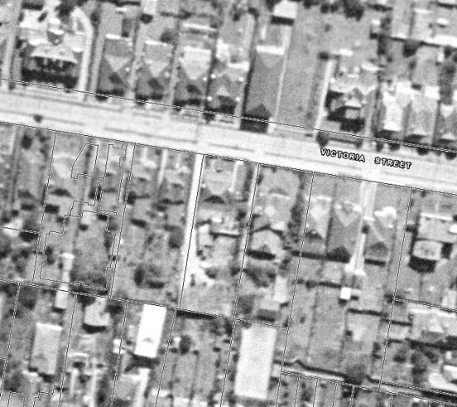
Figure 4: c1943 Aerial image of 28-34 Victoria Street, Burwood (Source: Six Maps).

State Environmental Planning Policy (Infrastructure) 2007
The aim of this Policy is to facilitate the effective delivery of infrastructure across the State, including electricity and road infrastructure.

The proposed development includes a car park with more than 200 parking spaces and is thus identified as traffic generating development pursuant to Schedule 3 of the SEPP. Transport for NSW (formerly RMS) have therefore been referred to for comment on the application. TfNSW have raised no objection to the proposed development subject to recommendations provided to Council.

State Environmental Planning Policy (Building Sustainability Index: Basix) 2004
The proposed amended development includes BASIX affected buildings. A compliant BASIX certificate has been submitted with the DA. In accordance with the Environmental Planning and Assessment Regulations 2000 the environmentally sustainable commitments within the amended BASIX certificate will be required to be fulfilled as a prescribed condition of consent.

Accordingly, subject to conditions, the proposal satisfies the provisions of SEPP BASIX.

State Environmental Planning Policy No. 65 – Design Quality Of Residential Apartment Development
SEPP 65 applies to the proposed development as it is characterised as ‘shop top housing’ and is three or more storeys and contains four or more dwellings. Clause 28(2) stipulates that the consent authority is to take into consideration the advice of a design review panel (if any), the design quality principles, and the Apartment Design Guide (ADG).

Council does not have a design review panel; however the application was referred to an external Urban Design consultant (GMU) who reviewed various iterations of the proposal. The issues raised by GMU in their final review of the proposal are listed below and are considered to have been addressed in the amended plans received by Council on 16 April 2020, 22 July 2020 and 12 August 2020 as discussed below:

Urban Design Consultant issues (summarised):

- Bulk and Scale
The building is proposed to reach 100.98m in height, which significantly exceeds the allowed 60m building height by Burwood LEP 2012. The tower presents a slender form and it appears to fit relatively well within the future context. However, the increase in height corresponds to a 67% increase in the allowable height. This requires concurrence from the council and a strongly documented clause 4.6 application.
The proposal will have a satisfactory contextual fit with the evolving skyline when viewed from the north. However, a sharp transition occurs when viewed from the west. GMU recommends further analysis to ensure adequate transition.

- Design Excellence
There seems to be an overly complicated link between the base and the tower at the entry point from Victoria Street, where the form curbs, wraps around and climbs up the façade. This is an unnecessary feature of the design.

- Connections and Through-site Link
A new pedestrian laneway is proposed, approximately 35m east to the one required by the council’s DCP. Through site links can improve the permeability of street blocks; however, two links in such proximity could be redundant.
The Design Excellence Submission (Urban Link), is inaccurate and required updating to assess the real opportunities and constraints of the site, which if understood correctly might lead to a different design approach for the site.

- Building Interface
The proposal presents two major activated frontages: one along Victoria Street and the other one along the newly created through site link. The interface facing the link appears to be more prominent than the one facing Victoria Street.
It is considered counterintuitive to activate a secondary entrance or facade away from the public street. Also, the adjacent property at 36-38 Victoria Street presents blank fences on the ground level, which will constitute a poor interface to the link. Potential noise issues to the surrounding residents will also be a concern.
The eastern podium is built to the site boundary with a zero-lot blank façade of over 50m in length to the neighbouring site.

- Waste Management
There is no clear path of travel for a number of tenants to the commercial waste room located at the south eastern corner of the building.
Bulky waste rooms on Basement 01 and Basement 02 plans are located too far from residential lifts. The proposed 179 units will require at least 268 m² of bulky waste area, which is far greater than the provided 59.62m².

- Deep Soil Planting
Only 1.6% of the site area is deep soil zone with over 6m width.
The podium and basement are built to the eastern boundary and will likely affect the long term health of trees located along this boundary.

- Internal Layout
GMU recommends to relocate the mailboxes to the sidewalls of the lobby to improve the resident’s arrival experience.

- Amenity
Deeply inset bedrooms with no direct sunlight are not ideal.
It appears that apartments on Level 3-20 and Level 28 are no naturally cross ventilated, as indicated on plans. Apartments on the Level 21-22 do not have windows indicated on the floor plans to allow cross ventilation.

- Carpark Provision
The total required parking spaces is 105, which is greater than the provided 89. There is an estimated deficit of 16 spaces.

- Floor Space Ratio Provision
The proposal achieves a total FSR of 4.95:1 and a residential FSR of 3.465:1. As per Burwood LEP 2012 Cl. 4.4A, the maximum total allowable FSR is 4.95:1 if the residential use does not exceed 70% of the total building GFA, with which the proposal complies. However, the LEP also requires that the maximum residential FSR does not exceed 3:1 whereas the subject site provides 3.465:1. In this regard, the proposal exceeds the LEP residential FSR provision.
Amended Plans received and Applicant’s response to Urban Design Consultant Issues (summarised):
- Bulk and Scale - Additional studies of west form has been provided to ensure of the contextual fit.

Comment: It is considered that the proposed height is acceptable in the context of the height and scale of surrounding approved developments. The increased height enables a slender tower form that reduces adverse impacts on neighbouring properties and increases residential amenity for future occupants.

- Design Excellence - The design has been amended to remove the connecting elements from the podium to the tower, as illustrated in the 3D renders below (amended façade detail outlined in red).

Original Render

Amended Render (amended façade design outlined in red)

- Connections and Through-site Link - The amended Design Excellence Report provides further details relating to location of the through site link prescribed by BDCP 2013. A through site link is not feasible in this location for the following reasons:
- Link exit on Victoria Street between driveways risk for pedestrian safety
- 36 Victoria Street egress does not allow for direct views for pedestrians through the site link. Interface along the car park is dark and unattractive with existing services and air-conditioning units
- Chair lift may be required to allow or disabled access to the large level difference between 29 George Street and 36 Victoria Street
- Limited direct disabled access from 29 George Street

Further analysis of pedestrian and traffic movements has also been provided.

GMU comment: GMU agrees with the increased permeability with a well-designed and fully accessible link; however, the utility of this link would be limited if it is not able to connect across the block to the street to the south.

Comment: Conditions of consent will require a through site link to be provided on site and accessible to the public. This will connect with the adjoining site (No. 23-27 George Street) once that development is constructed, in accordance with detailed design to be approved by Council.

- Building Interface - Although the building interface to the western through site link is prominent, this does not detract from the quality of the Victoria Street frontage. The development is anticipated to attract foot traffic from Victoria Street predominately as it is a direct branch from Burwood Road, which creates the north-south axis through the Burwood Town Centre. Further, the ground floor and podium levels on the northern and western elevations do not present sharp corners to the public domain. Rather, the design has adopted a curved facade to create a cohesive and integrated presentation to the public domain to Victoria Street to the north, flowing seamlessly to the through site link to the west.

The proposal is well placed to provide an integrated through site link in conjunction with the property at 36-38 Victoria Street. This property is under the same ownership as that of 28-34 Victoria Street and as such is in a good position to provide upgrade works to the eastern elevation to accommodate the through site link, which will include landscaping in planter boxes to match the design of the through site link and removal of the blank fence.

The Acoustic Report provided with the DA conducted an assessment of intrusive noise. The acoustic treatments recommended in the report will also result in the reduction of acoustic impacts to neighbouring properties.

The eastern elevation has been set back 3m on its entire length from a zero lot line to reduce the visual impact of the development to the east and softens the transition along the eastern boundary. This is combined with the provision of deep soil hard landscaping to this setback which will soften the appearance of the podium area. Windows and glazing have now been provided to the eastern elevation of the podium to reduce the impact of the blank façade.

GMU comment: The Applicant has recessed the eastern boundary by three metres to include a strip of deep-soil along the edge of the boundary. The additional setback could go some way to mitigate the issue and assist with the preservation of the existing trees on the neighbouring property. However, the proposed podium still encroaches the Tree Protection Zone. We recommend that Council’s Arborist and Landscape Officer comment on the effectiveness of the 3-metre setback in achieving the preservation and well-being of the trees.

With regards to the pedestrian link activation, GMU considers it not a major issue if the through-site pedestrian link could be realized. The Applicant has to provide evidence of the potential link going through across the block as discussed earlier in these comments.

Comment: Council’s Tree and Landscape Officer have assessed the amended proposal and raised no objections subject to conditions of consent.

Per the above comments, the through site link will be secured by conditions of consent. This has been considered in relation to the approval at No. 23-27 George Street (DA.2016.179), where a through site link was approved which will connect with the proposed through site link.

- Waste Management - Level 1 and 2 are proposed to manually take waste to commercial waste room on the Ground Level. Bulky storage areas have been amended on Basement Level 2 to allow for improved proximity to lifts.

Comment: Council’s Environmental Health Officer has assessed the amended proposal and has raised no objection to the proposed waste management arrangements, including the amount of bulky waste areas provided on site, subject to recommended conditions of consent.

- Deep Soil Planting - As noted above, an additional 3m deep soil area has been provided on the eastern side of the development. Deep soil areas proposed are now:
  - Deep soil (6x6m) provided is 7.7% - 325m²
  - Deep soil (5x5) provided is 0.8%- 33m²
  - Deep soil (3x3m) provided is 4.3% - 183m²

Comment: Deep soil now complies with the ADG requirement.

- Internal Layout - The mailboxes have been relocated within the lobby to allow for signage and/or lobby artwork to be provided.

- Amenity - Solar access and cross ventilation diagrams have been updated. The applicant provides that 125 (70%) of apartments received natural cross ventilation.

Comment: An assessment of apartments on the first 9 levels of the development found that 34 out of 48 (71%) of apartments received natural cross ventilation, which is compliant with the ADG. Per the ADG, apartments above the ninth storey are deemed to be cross ventilated.

- Car Park Provision - The proposed development provides the following floor space areas and car parking numbers:

Residential:
  - 1 Bedroom – 46 x 1 = 46 spaces
  - 2 Bedroom – 106 x 1 = 106 spaces
  - 3 Bedroom – 27 x 1.5 = 41 spaces
  - Visitors – 179 / 5 = 36 spaces
  - Total Required = 193 residential and 36 visitor spaces
  - Proposed = 193 residential spaces and 36 visitor spaces

Non-Residential Requirements:
  - Restaurant / Café – 1,416sq.m = 26 spaces
  - Retail – 2,392sq.m = 51 spaces
  - Office – 1,487sq.m = 10 spaces
  - Total Required = 87 non-residential spaces
  - Proposed = 87 non-residential spaces

Comment: The proposed car parking provided is compliant with the parking rates contained in BDCP 2013.

- Floor Space Ratio

Planner comment: The proposal provides 20,990m² of GFA, with 6,283m² (30%) being non-residential GFA. This equates to an FSR of 4.95:1. A monetary contribution towards community infrastructure will be provided as part of a VPA, to be secured by condition of consent. The development is therefore compliant with Clause 4.4A of BLEP 2012, which prescribes an FSR of 4.95:1 for the site.
The amended plans and documentation are considered to satisfy the issues raised by Council’s Urban Design Consultant and in this regard, re-referral of the amended plans was not considered necessary. These amended plans form the basis of this assessment report.

Design Quality Principles

The amended proposal as detailed above has been assessed against the Design Quality Principles. The proposal is considered to be consistent with the Design Quality Principles and a Design Verification Statement was submitted with the application prepared by Urban Link dated 27 September 2019, outlined in Table 1 below.

Table 1: Design Quality Principles and Applicant’s Response
Principle | Comment | Consistency
Principle 1: Context and neighbourhood character  Good design responds and contributes to its context. Context is the key natural and built features of an area, their relationship and the character they create when combined. It also includes social, economic, health and environmental conditions.  Responding to context involves identifying the desirable elements of an area’s existing or future character. Well designed buildings respond to and enhance the qualities and identity of the area including the adjacent sites, streetscape and neighbourhood.  Consideration of local context is important for all sites, including sites in established areas, those undergoing change or identified for change. | Applicant’s response:  The surrounding area is characterised by a mix of building forms and styles including, low scale residential housing (of brick and fibro), mixed use developments and services such as schools and train station.  The area is undergoing a significant transition into a higher density area consisting of medical, education, retail, commercial and residential uses. It is likely that the area will experience a transition in densities such as that proposed in this application to meet the objectives of the Burwood Town Centre controls. Within this context the proposal will sit well, contribute and act as a precedence in a positive manner to the quality and identity of the precinct.  The zoning and relevant built form controls allow for the style of building proposed and responds to the desired future character as articulated by the DCP. | Yes
Principle 2: Built form and scale  Good design achieves a scale, bulk and height appropriate to the existing or desired future character of the street and surrounding buildings.  Good design also achieves an appropriate built form for a site and the building’s purpose in terms of building alignments, proportions, building type, articulation and the manipulation of building elements.  Appropriate built form defines the public domain, contributes to the character of streetscapes and parks, including their views and vistas, and provides internal amenity and outlook. | Applicant’s response:  The building scale, bulk and height responds to the future character of the street and surrounding buildings.  The building sits below the DCP height planes including the 36⁰ Shaftesbury Rd plane that was put in place to mitigate overshadowing over the R2 zone.  The building fits well with the desired streetscape in term of bulk, scale. The bulk and scale of the building is ameliorated with the building being articulated through the composition of elements and materials to create less perceived bulk to the building. The building massing and facades are articulated to break down the scale and create a building identity, while maintaining the surrounding amenity.  The street will have vegetation over the promenade to contrast and soften the experience at a human scale, adding positively to the public domain. The proposed thoroughfare will consist of deep soil zones that allow for growth of large trees to mitigate visual and acoustic privacy as well as providing a pleasurable experience for the occupants of the space.  Multiple communal open spaces with different offerings on level 3 and level 21 provide excellent internal amenity and outlook. | Yes
Principle 3: Density  Good design achieves an appropriate built form for a site and the building’s purpose, in terms of building alignments, proportions, building type and the manipulation of building elements.  Appropriate built form defines the public domain, contributes to the character of streetscapes and parks, including their views and vistas, and provides internal amenity and outlook | Applicant’s response:  The achieved density is a function of the tangible public benefits under council’s current Sydney Region Growth Centre SEPP. The proposed building is an opportunity to achieve density that is consistent with the desired future character of the area and can be sustained by excellent access to public transport, amenities and jobs.  The proposed density is appropriate to its location, meets the minimum densities as defined in the DCP and in the context of the neighbouring buildings. It makes good use of its proximity to public transport via train and bus, amenities and jobs. | Yes
Principle 4: Sustainability  Good design combines positive environmental, social and economic outcomes.  Good sustainable design includes use of natural cross ventilation and sunlight for the amenity and liveability of residents and passive thermal design for ventilation, heating and cooling reducing reliance on technology and operation costs. Other elements include recycling and reuse of materials and waste, use of sustainable materials and deep soil zones for groundwater recharge and vegetation. | Applicant’s response:  It is apparent that the proposal promotes the longer term sustainability of the local area  Natural ventilation compliance under the ADG is achieved by suitably designed double oriented apartments with reliable exposure to the relevant summer cooling breezes in Burwood.  Over 2 hours of sun are provided to majority of units between 9-3pm on the 21st June as per the ADG guidelines and a significant proportion achieve some sunlight between these hours. Balconies provide shelter from the summer sun while allowing winter sun to penetrate well into living areas. This will reduce the need for mechanical heating and cooling.  Communal open space is provided at level 3 and 21 terrace receiving the required hours of solar. | Yes
Principle 5: Landscape  Good design recognises that together landscape and buildings operate as an integrated and sustainable system, resulting in attractive developments with good amenity. A positive image and contextual fit of well designed developments is achieved by contributing to the landscape character of the streetscape and neighbourhood.  Good landscape design enhances the development’s environmental performance by retaining positive natural features which contribute to the local context, co-ordinating water and soil management, solar access, micro-climate, tree canopy, habitat values and preserving green networks.  Good landscape design optimises useability, privacy and opportunities for social interaction, equitable access, respect for neighbours’ amenity and provides for practical establishment and long term management. | Applicant’s response:  All of the proposed units still have access to outdoor balconies and/or terraces, some with various aspects. Communal open spaces on level 3 and 21 terraces are incorporated into the development providing a range of recreational opportunities for future residents.  Large canopy trees are provided along the thoroughfare and partly on the main road, continuing the existing green spine on Victoria St. Planter boxes are also provided along the top of the promenade to provide an inviting green belt. | Yes
Principle 6: Amenity  Good design positively influences internal and external amenity for residents and neighbours. Achieving good amenity contributes to positive living environments and resident well being.  Good amenity combines appropriate room dimensions and shapes, access to sunlight, natural ventilation, outlook, visual and acoustic privacy, storage, indoor and outdoor space, efficient layouts and service areas and ease of access for all age groups and degrees of mobility. | Applicant’s response:  The proposed units will still have considerable internal amenity and achieves the minimum sizes contained within the Apartment Design Guide. They are of a sufficient size and appropriate room dimensions to meet the needs of future occupants. Storage is provided within all units and with some additional space within the basements. The outdoor areas (communal and private) are of sufficient size to meet the recreational needs of future occupants.  The building has been designed in compliance with the principal development standards to achieve high levels of internal and external amenity with more than 70% of units achieving the solar access requirements, and over 60% to achieve cross ventilation.  The proposed building has been provided with setbacks to limit overshadowing, maximise solar access and minimise privacy and overlooking impacts. | Yes
Principle 7: Safety  Good design optimises safety and security within the development and the public domain. It provides for quality public and private spaces that are clearly defined and fit for the intended purpose. Opportunities to maximise passive surveillance of public and communal areas promote safety.  A positive relationship between public and private spaces is achieved through clearly defined secure access points and well lit and visible areas that are easily maintained and appropriate to the location and purpose. | Applicant’s response:  The principles of Crime Prevention through Environmental, Design include the consideration of Natural Surveillance, Natural Access Control and Natural Territorial Reinforcement as demonstrated below:  Surveillance - The development embodies good levels of casual surveillance from within the building and from the street. The proposed building and landscaping design do not create any concealment areas.  Access - The main ground level entry will be secured and fitted with a telecom for visitors. The entry to the building lobby is accessed from the street frontages of the property and is fully glazed, maximizing the potential for casual surveillance. Access to the basement is by a secured roller door, which again is fitted with an intercom entry system for visitors. Access from secured garages is available to all units above. The lifts will be restricted to resident use only by coded key cards and similarly for commercially dedicated lifts. Generally, the proposed layout provides a high level of privacy and security. Adequate lighting to be provided for the lobby, car parks and communal open spaces, details will be submitted with the CC documents.  Territorial Reinforcement:  The proposed development and its presentation to the street make it clearly identifiable by the public. The proposed development is considered to represent a satisfactory outcome in terms of security and crime prevention.  We can conclude that the proposed development has been designed in accordance with the objectives and better design practice of the Crime Prevention through Environmental Design (CPTED). | Yes
Principle 8: Housing diversity and social interaction  Good design achieves a mix of apartment sizes, providing housing choice for different demographics, living needs and household budgets.  Well designed apartment developments respond to social context by providing housing and facilities to suit the existing and future social mix.  Good design involves practical and flexible features, including different types of communal spaces for a broad range of people and providing opportunities for social interaction among residents | Applicant’s response:  The proposed design incorporates various dwelling sizes and shapes, with units capable of adaption and meeting the liveable housing level required, thereby promoting diversity, affordability and access to housing choice. | Yes
Principle 9: Aesthetics  Good design achieves a built form that has good proportions and a balanced composition of elements, reflecting the internal layout and structure. Good design uses a variety of materials, colours and textures.  The visual appearance of a well designed apartment development responds to the existing or future local context, particularly desirable elements and repetitions of the streetscape. | Applicant’s response:  As discussed in the Architect Design Statement the design has an excellent composition of elements to create a highly articulated façade and of high aesthetic value.  Finishes have been selected to compliment the elements they envelope and to create a modern yet not overpowering contribution to the streetscape and architectural quality in the area.  Bulk and scale is controlled through use of elements such as blades, projected balconies with transparent, and solid balustrade, a feature textured ‘ribbon balcony. The podium elements are empathetic to the streetscape of Burwood Rd and ground the building to create a human scale at ground level. | Yes

Apartment Design Guide (ADG)

As the proposed development contains a residential flat building of three or more storeys and four or more dwellings, the provisions of the Apartment Design Guide (ADG) are applicable. The ADG contains objectives, design criteria and design guidelines for residential apartment development. The development has been assessed against the relevant key design criteria within Parts 3 and 4 of the ADG in Table 2 below:

Table 2: Assessment of the proposed development against the ADG
Objective | Requirement | Proposed | Compliance
3D  Communal Open Space | Communal open space has a minimum area equal to 25% of the site.  Developments achieve a minimum of 50% direct sunlight to the principal usable part of the communal open space for a minimum of 2 hours between 9 am and 3pm on 21 June (mid-winter). | The site has an area of 4,235m².  The proposed communal open space is located above podium on Level 3 (1,352m²) and on Levels 21 (214m²) and 23 (209m²), and comprises a total area of 1,775m², being 41.9% of the site area.  The communal open space at Level 3 will have a northerly aspect and thus, at least 50% of the principal usable area of the communal open space areas will receive solar access for a minimum of 2 hours between 9am and 3pm on 21 June in accordance with the requirement. | Yes  Yes
3E  Deep Soil Zones | On sites with areas >1,500m², 7% of the site area is to be deep soil with a minimum 6m dimension. | The development proposes 7.7% (326m²) of the site area as deep soil planting with minimum dimensions of 6m.  A further 182 (4.3%) of deep soil is proposed with a minimum dimension of 3m. | Yes
3F  Visual Privacy | The ADG prescribes minimum separation distances between buildings:  - Up to 12m (4 storeys) - 6m (habitable) / 3m (non-habitable)  - Up to 25m (5-8 storeys) - 9m (Habitable) / 4.5m (non-habitable)  - Over 25m (9+ storeys) - 12m (Habitable) / 6m (non-habitable)  No separation is required between blank walls. | The proposed building has the following minimum setbacks:  East:  Ground – Level 3 = 3m  Levels 4 - 28 = 28.5m  South:  Ground = Nil – 0.6m  Levels 1 - 3 = 6.4m  Levels 4 - 28 = 11.9m - 12m  West:  Ground – Level 3 = 6m  Levels 4 - 29 = 18.4m  North:  Ground – Level 3 = 3m  Levels 4 - 29 = 5.7m  The proposal provides compliant building separation to the western shared boundary. It also provides compliant setbacks to the eastern boundary from Level 4 and above, and compliant separation to the southern boundary from Level 1 and above. There is a nil separation for part of the ground floor of the building to the southern boundary, however this for a blank wall and non-trafficable roof and is thus compliant with the ADG requirements.  As such, there is a non-compliance from Ground – Level 3 on the eastern side and on all levels to the northern boundary. There non-compliances are considered to be acceptable on merit as described below:  - The northern boundary is the Victoria Street frontage and thus having a lesser setback from this frontage provides a better streetscape outcome and improved passive surveillance opportunities;  - Westfield Burwood is located on the opposite side of Victoria Street and has a blank façade facing the site. Further, it some 18m from the northern boundary of the site. Thus, the combined building separation is compliant with the ADG numerical requirement;  - The eastern elevation from Level 1 to Level 3 will contain non-residential uses and residential communal open space. No. 24-26 Victoria Street is located some 8m east of the shared boundary, providing a combined building separation of 11m to the proposed building. Conditions of consent will require that windows on the eastern elevation at Levels 1 and 2 incorporate privacy screens/louvres to limit outward views. Furthermore, the communal open space incorporates planting the edges and a 1.2m high wall to the edge of the building. Thus, it will limit overlooking across the eastern boundary towards No. 24-26. Visual privacy is further protected due to mature trees that exist along the eastern boundary. As such, levels of visual privacy enjoyed by neighbouring occupants of No. 24-26 will not be adversely impacted by the proposed development. | On Merit
3J Bicycle and car parking | 1. For development in the following locations:  • on sites that are within 800 metres of a railway station or light rail stop in the Sydney Metropolitan Area  GTTGD rates  - 0.6 spaces per 1 bedroom unit.  - 0.9 spaces per 2 bedroom unit.  - 1.40 spaces per 3 bedroom unit.  - 1 space per 5 units (visitor parking). | The proposal requires the following under the GTTGD:  - 47 x 1 bed = 24.6  - 105 x 2 bed = 94.5  - 27 x 3 bed = 37.8  - Visitor = 35.8  Total required = 157 residential and 36 visitor spaces  Proposed = 193 residential and 36 visitor spaces | Yes
4A  Solar and Daylight Access | Living rooms and private open space areas of at least 70% of apartments receive a minimum of 2 hours direct sunlight between 9am and 3pm at mid-winter.  A maximum of 15% of apartments in a building receive no direct sunlight between 9am and 3pm at midwinter. | 136 out of 179 or 76% of apartments receive a minimum of 2 hours direct sunlight between 9am and 3pm at mid-winter.  No apartments receive no direct light to the habitable areas in mid-winter. | Yes  Yes
4B  Natural Ventilation | At least 60% of apartments are naturally cross ventilated in the first nine storeys of the building. Apartments at ten storeys or greater are deemed to be cross ventilated  Overall depth of a cross-over or cross-through apartment does not exceed 18m measured glass line to glass line. | There are 48 apartments on the first nine storeys of the development. 34 of 48 or 71% of apartments in the first nine storeys are naturally cross ventilated.  No cross-through or cross-over apartments are proposed. | Yes  N/A
4C  Ceiling Heights | Habitable rooms: 2.7m.  Non-habitable: 2.4m.  If located in mixed use areas: 3.3m for ground and first floor to promote future flexibility of use. | The following floor to ceiling heights are proposed:  - Ground Level = 4.9m  - Level 1 = 3.3m  - Level 2 = 3.5m  - Level 3 = 2.7m  - Level 4 and above = 2.8m | Yes
4D  Apartment Size and Layout | Apartments are required to have the following minimum internal areas:  Studios: 35m²  1 bedroom: 50m²  2 bedroom: 70m²  3 bedroom: 90m²  The minimum internal areas include only one bathroom. Additional bathrooms increase the minimum internal area by 5m².  Every habitable room must have a window in an external wall with a total minimum glass area of not less than 10% of the floor area of the room.  In open plan layouts (where the living, dining and kitchen are combined) the maximum habitable room depth is 8 metres from a window.  Master bedrooms have a minimum area of 10m² and other bedrooms 9m² (excluding wardrobe space). Bedrooms are to have a minimum dimension of 3m.  Living rooms or combined living/dining rooms have a minimum width of: 3.6m for studio and 1 bedroom apartments, 4m for 2 and 3 bedroom apartments.  The width of cross-over or cross-through apartments are at least 4m internally to avoid deep narrow apartment layouts. | The proposed development consists of 1, 2 and 3 bedroom units.  1 bedroom units are between 52-54sq.m.  2 bedroom units are between 75-111sq.m.  3 bedroom units are between 95-117sq.m.  Additional bathrooms have been taken into account. All units are in excess of the minimum areas for apartment sizes under the ADG.  Each habitable room has a window that complies with this requirement.  Open plan kitchen, living and dining areas are proposed for all apartments and have a maximum room depth of 8 metres from a window.  Proposed master bedrooms have a minimum area of 10m² and other bedrooms 9m² (excluding wardrobe space). Bedrooms are to have a minimum dimension of 3m.  The proposed development complies with these requirements.  No cross-through apartments are proposed. | Yes  Yes  Yes  Yes  Yes  Yes  No
4E  Private Open Space and Balconies | All apartments are required to have primary balconies as follows:  Studios: 4m² minimum area.  1 bedroom apartments: 8m² minimum area, 2m minimum depth.  2 bedroom apartments: 10m² minimum area, 2m minimum depth.  3+ bedroom apartments: 12m² minimum area, 2.4m minimum depth.  Ground level or podium apartments are to have a minimum POS area of 15sq.m and minimum depth of 3m. | All apartments are provided with primary balconies that comply with the minimum area and minimum depth as per the requirements.  The majority of podium level apartments have a minimum POS area of at least 15sq.m and a minimum depth of 3m.  However Units 3.07 and 3.08 both only have a private terrace of 12sq.m. This is considered to be acceptable in this instance given that both are 1-bedroom apartments and do not face directly onto podium level communal open space. | Yes  Yes  On Merit
4F  Common Circulation and Spaces | The maximum number of apartments off a circulation core on a single level is eight.  For buildings of 10 storeys and over, the maximum number of apartments sharing a single lift is 40. | The maximum number of units off a circulation core is 8. A single residential circulation core with four lifts is provided for the development.  Four lifts are provided for 179 apartments, providing an average of 45 apartments per lift. This non-compliance is minor and considered to be acceptable in this instance given that the number of apartments per circulation core is compliant and separate non-residential lifts are provided. | Yes  On Merit
4G  Storage | In addition to storage in kitchens, bathrooms and bedrooms, the following storage is provided:  Studio: 4m³  1 bedroom: 6m³  2 bedroom: 8m³  3+ bedroom: 10m³  At least 50% of the required storage is to be located within the apartment. | The development provides sufficient storage within apartments and within the basement for each unit as required by the ADG. | Yes
4K  Apartment Mix | A variety of apartment types are provided. | A mixture of 1, 2 and 3 bedrooms are proposed as follows:  - 46 x 1 bedroom apartments;  - 106 x 2 bedroom apartments; and  - 27 x 3 bedroom apartments. | Yes

Burwood Local Environmental Plan 2012
The Burwood Local Environmental Plan 2012 came into effect on 9 November 2012. Burwood LEP 2012 contains a number of controls including some numerical development standards which apply to the proposed development. A summary of the assessment of the application against the relevant planning controls within LEP 2012 is shown in Table 3 below.

Table 3: Assessment of the proposed development against Burwood LEP 2012
Clause | Assessment of Proposal | Compliance
2.3 Zone objectives and Land Use Table  B4 Mixed Use | The proposed land use is characterised as a ‘shop top housing’ and is permitted with consent in the B4 zone.  The development satisfies the objectives of the zone as it will provide a mixture of compatible uses, including 179 new apartments in various sizes and layouts, and various non-residential tenancies.  The development will maximise public transport patronage and encourage active transport as it will provide more dwellings and employment opportunities within walking distance of the Burwood Railway Station and with access to the wide range of services and facilities within the Burwood Town Centre. | Yes
4.1 Minimum subdivision lot size  Minimum 500 square metres | The proposal will amalgamate three existing lots into one lot which will have a site area of 4,235m². | Yes
4.3 Height of Buildings  Maximum 60 metres | The proposed development will have a maximum height of 100.98m which does not comply with the maximum height prescribed by Clause 4.3. However, the development relies on height exceptions pursuant to Clause 4.3A, as described below. | No
4.3A Building Height Plane  Height is not to exceed the building height plane in “Area A”..  BHP projects west from a starting height of 1m from the eastern side of Shaftesbury Road at 36 degrees across the site. | The site is located within “Area A” and therefore, Clause 4.3A applies to the development.  The development complies with Clause 4.3A Building Height Plane, refer to elevation plan DA-205 D. | Yes
4.4 Floor space ratio Maximum 4.5:1 | The development proposes an FSR of 4.95:1.  - GFA: 20,990m²  - Site Area: 4,240.6m² (per survey)  This does not comply with the maximum FSR prescribed by Clause 4.3. However, the development relies on FSR exceptions pursuant to Clause 4.4A, as described below. | No
4.4A Exceptions to Floor space ratio  FSR of 4.95:1 in “Area 2” if residential accommodation does not exceed 70 percent of the total gross floor area and proposed development includes community infrastructure. | The site is located in “Area 2” and the proposed FSR is 4.95:1, comprising of:  - 6,283m² (30%) of non-residential GFA  - 14,707m² (70%) of residential GFA  A draft VPA has been approved by Council to secure a monetary contribution of $3,337,775 towards community facilities. A condition of consent will require the VPA to be executed prior to commencement of development. | Yes
5.1 Relevant acquisition authority  Land reserved to be acquired for public purposes | N/A – The subject site is not identified on the Land Reservation Acquisition Maps. | N/A
5.10 Heritage Conservation  Various requirements for development of heritage items, heritage conservation area, or within the vicinity of heritage items. | The site does not contain a heritage item and is not located in a Heritage Conservation Area (HCA).  However the site is located within the vicinity of a number of local heritage items.  To the south-east of the site is I56 – being No. 9 and 11 George Street, Burwood which is a pair of Victorian semi-detached houses.  Four heritage items are located on Burwood Road, approximately 140m due west of the site. These are:  I17 – being Nos. 55–55A, 57 and 59 Burwood Road, Burwood. Comprising of shops on the western side of the road.  I18 – being Nos. 71–77 Burwood Road, Burwood. Victorian shop frontages also on the western side of the road.  I20 – being No. 134A Burwood Road, Burwood. This comprises of the “Congregational (Uniting) Church and Church Hall” on the eastern side of the road.  I223 – being Nos. 122–126 Burwood Road, Burwood. Comprising of “Ely House”—first floor facade, including balconies, windows, window shutters and roof (facing Burwood Road and Victoria Street), also located on the eastern side of the road.  A Heritage Impact Statement (HIS) prepared by Weir Philips Heritage and Planning dated August 2019, was submitted with the application. The HIS concludes that:  “The subject property has been identified as located within the vicinity of the several locally listed items. However, as identified within this report, the proposed podium of the development respects the prevailing height and scale of the street, the modern design does not seek to replicate or mimic any of the characteristics of the neighbouring heritage listed items and will not block or impede any views to or from the heritage items. The proposed development is consistent with the characteristics and appearance of the evolving urban setting of the items.  Accordingly, it is considered that the proposed works will have no impact on the significance view corridors or general setting of the nearby heritage items.  The proposed works fulfil the objectives for works to heritage items and in the vicinity of heritage items set out by the Burwood LEP 2012 and the Burwood DCP 2013.”  The originally submitted application was referred to Council’s Heritage Advisor who requested additional information relating to overshadowing of nearby heritage items and a view analysis in relation to No. 134A Burwood Road.  This was provided as part of the amended application, which was referred to Council’s Heritage Advisor, who has raised no objection to the amended development, subject to conditions of consent which have been imposed in the attached schedule. | Yes
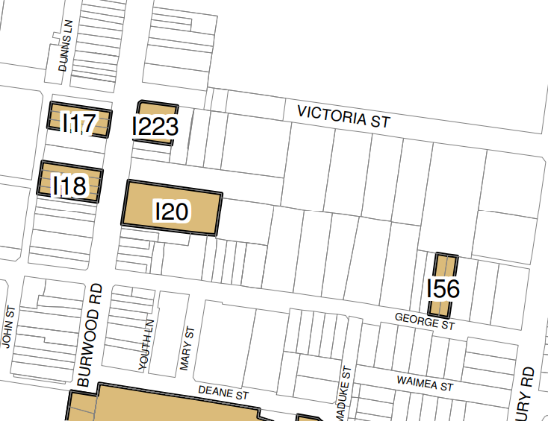
Subject site
Figure 5: BLEP 2012 – Heritage Map.
6.1 Acid Sulfate Soils  Various requirements depending on ASS class | The site is identified as Class 5 Acid Sulfate Soils. The subject site is not located within 500m of Class 1, 2, 3 and 4 land. Given the levels of the proposed basement are well above 0m AHD (approximately RL 5.7 AHD proposed for Basement Level 4), the water table is unlikely to be lowered.  Accordingly, an Acid Sulfate Soils Management Plan is not required. | Yes
6.3 Active Street Frontages | N/A – The subject site is not identified as requiring an Active Street Frontage. | N/A
6.5 Design Excellence in B2 and B4 | A Design Excellence Peer Review has been prepared by DKO Architects and addresses Clause 6.5 of BLEP 2012, as summarised below:  - The building massing and architectural design demonstrates references to the established characteristics such materiality and detailing appropriate to its context. The proposed landscape and urban design demonstrates a high quality and amenity for multiple users of the building;  - Public art has been incorporated into the public domain and the curved form will mitigate wind impacts at ground plane. Retail tenancies and outdoor seating opportunities will activate the street and through site link;  - The podium architectural response demonstrates references to the materiality, patternation and modulation of the established characteristics of its surroundings. The slender massing design of the proposal has taken steps to mitigate overshadowing to nearby heritage items and southern developments in general.  - The perceived bulk from Burwood Road view to the heritage item 120-congregational (uniting) church is mitigated with a stepped built form to the south to represent a slender massing.  - Proposed shared vehicular and service vehicle access at the North Eastern corner of the site located away from pedestrian movement is favourable. Separate dedicated entries for both residential and commercial use addressing Victoria Street is a suitable outcome.  - The proposed public through site link supports a direct a link to the Burwood train Station. An activated edge addressing this link, with consideration of amenity and usability of spaces supporting the thoroughfare demonstrates a quality experience for the public.  - Distribution of diverse open spaces for the public use, commercial use and residential use at multiple levels supports the mixed use nature of the subject site.  - Stepping of the built form to the south is perceived to mitigate overshadowing impacts and reduce perceived bulk from key urban views. The extended building separation to the East and modulation of the tower massing to create smaller vertical forms demonstrate mitigation of overshadowing in the afternoon to the R2 zone to the East. This vertical modulation further articulates the massing break-up.  - A high standard of sustainable design has been considered. Passive solar shading to the building façade design, provision for solar arrays located on the rooftop for alternative forms for energy source, and measures for wind mitigation has been satisfied.  In summary, the proposal as amended is considered to exhibit design excellence and achieves the requirements of this clause. As discussed in this report, the proposal is consistent with the Design Quality Principles of the ADG. | Yes

Burwood Development Control Plan 2013
The Burwood Development Control Plan 2013 (BDCP) applies to the proposed development. A summary of the assessment of the application against the relevant planning controls and objectives within BDCP is shown in Table 4 below.

Table 4: Assessment of the proposed development against Burwood DCP 2013
Provision | Assessment of Proposal | Compliance
Part 2 Site and Environmental Planning
2.2 General Site Analysis  - To be provided with a Development Application. | A site analysis has been prepared by Urban Link and accompanies the application. | Yes
2.3 Views and Vistas  - Development applications must identify existing views and vistas significant to the proposal, assess the impacts of the development and demonstrate how significant views and vistas area to be protected and enhanced;  - Developments must have particular regard to high quality and priority views and vistas identified in other parts of this DCP, e.g. In relation to heritage items and heritage conservation areas. | The proposed development adopts appropriate front, rear and side setbacks. The scale of the proposal is reasonably expected in light of the controls that apply to the site, being compliant with FSR and building height plane controls under the LEP. As such, it is not considered that the development will give rise to any unacceptable view impacts on adjoining properties or nearby public spaces.  In terms of priority views, view analysis has been undertaken by the applicant in relation to nearby heritage items. The proposed development will not prejudice the setting of heritage items in the vicinity, particularly the setting of the “Congregational (Uniting) Church and Church Hall” at No. 134A Burwood Road, Burwood. Further, it is noted that the heritage items at No. 9 and 11 George Street have been approved for redevelopment (DA.2016.98), including an 18 storey tower above. This will block views from those heritage listed dwellings to the proposed development. | Yes
2.4 Streetscapes  - Development Applications must identify streetscape characteristics, assess the impacts of the development and demonstrate how significant streetscape qualities are to be protected and enhanced;  - Development Applications must demonstrate how building design, location and landscaping will encourage the protection and enhancements of streetscape;  - Development must have particular regard to high quality streetscapes identified in other parts of this DCP e.g. in relation to heritage items and conservation areas | The appearance of the proposed building is considered to be compatible with the emerging character of the streetscape and wider Burwood Town Centre Precinct, where a number of sites have been approved or are currently being redeveloped for high rise mixed use developments.  The streetscape is undergoing, or expected to experience, significant transformation in terms of built form and urban context. In this regard, the proposal is consistent with the anticipated future character of the area and will therefore enhance the streetscape.  The development will not adversely impact on the setting of nearby heritage items, as discussed in the LEP compliance table above. | Yes
Part 3 Development in Centres and Corridors
3.2.1 Building Design  O1 To ensure that new buildings:  - Represent architectural and urban design excellence.  - Provide cohesive and visually interesting building appearance.  - Respond to surrounding notable buildings and enhances the streetscape.  - Integrate roof design with the building character and enhances the skyline.  - Encourage rooftop gardens and planting on structures that enhance the quality and amenity of open space. | The development proposal has been assessed by GMU and, following amendments to the development was found to be satisfactory.  The building design has been significantly improved throughout the assessment process, and now provides a 3 storey podium that activates Victoria Street and the proposed through site link. Increased building setbacks to the eastern side will ensure that mature trees along that boundary are retained on site. This is in addition to landscaping and public domain enhancements proposed throughout the development, including landscaping on grade and on structure.  The amended proposal provides a slender residential tower that will be compatible with the emerging character of Burwood Town Centre and will provide a high quality amenity to residential and non-residential uses. | Yes
3.2.2 Materials and Finishes
O1 To ensure that the use of superior quality external materials and finishes:  - Contributes to architectural and urban design excellence.  - Provides cohesive and visually interesting building appearance.  - Responds to surrounding notable buildings and enhances the streetscape.  - Provides longevity in external materials and finishes that are of superior quality. | The proposed materials, modulation and façade design, ensure the street elevations are well articulated and will have a positive visual impact on the streetscape and is compatible with the character of development envisaged in the Burwood Town Centre.  The 3 storey podium will contain face brick and masonry to be compatible with surrounding brick built buildings and will respect the heritage significance of nearby heritage items. | Yes
3.2.3 Lighting and Signage
O1 To ensure that that building lighting and signage:  - Contribute to architectural and urban design excellence.  - Provide cohesive and visually interesting building appearance. | Lighting and signage details have not been provided as part of the subject DA. A condition of consent is recommended specifying details of lighting to be provided to ensure consistency with the relevant BDCP provisions, including for public domain lighting. | Yes, subject to condition.
3.2.4 Street-Front Activities and Building Access  O1 To encourage pedestrian safety, visual interest and activity at street level.  O2 To promote street front activities, especially along streets of high pedestrian use.  O3 To create building entrances that are safe and contribute positively to the streetscape and building façade design. | The development incorporates activation to all edges of the proposed building, including residential and non-residential windows that overlook Victoria Street and the proposed through site link. This provides good levels of passive surveillance in the vicinity of the site.  A high degree of activation is provided through the design and uses within the podium. This includes opportunities for outdoor dining as well as public domain enhancements.  Pedestrian and vehicular entry points are physically separated and clearly defined to avoid conflict between pedestrians and vehicles. Residential and non-residential lobbies and lift cores are also separated from one another. Mail boxes are provided within the residential lobby entry off Victoria Street.  A CPTED assessment accompanies the application and sets out recommendations for the development, including installation of CCTV cameras, access controls, and appropriate lighting. | Yes
3.2.5 Subdivision and Car Parking Spaces | N/A – no subdivision proposed. | N/A
3.2.6 Site Isolation  P1 The creation of isolated sites is discouraged. | The proposal will not isolate any sites as the adjoining sites have sufficient size and dimensions for future redevelopment. | Yes
3.2.7 Residential Flat Buildings and Shop Top Housing  P1 For any shop top housing, there is no numerical relationship between the number of dwellings and the ground floor retail or business premises. | The proposal includes non-residential uses, including tenancies appropriate for retail, food and drink premises and office space at podium level, with 179 residential apartments in the tower above. | Yes
3.2.8 Apartment Mix and Minimum Dwelling Sizes | The proposal provides for 179 apartments containing a mixture of one, two and three bedroom apartments as follows:  - 46 x 1 bedroom (26%);  - 106 x 2 bedroom(59%); and  - 27 x 3 bedroom (15%). | Yes
P1 Residential development in excess of 20 dwellings must provide a mix of dwellings containing one, two or more bedrooms. |  | Yes
3.2.9 Minimum Site Area
P1 Any development outside a Centre with a height over 9m is generally required to have a minimum site area of 500 square metre. | The subject site has an area of 4,235m². | Yes
3.2.11 Ceiling Height  P1 Development must provide the following minimum ceiling heights. Dimensions are expressed from finished floor levels to finished ceiling levels:  - Ground level of all development (commercial and residential): 3.3 metres.  - Non-residential floors above ground level: 3.0 metres.  - Residential floors above ground level: 2.7 metres for habitable rooms and 2.4 metres for non-habitable rooms. | The proposed development complies with the minimum ceiling heights, with all non-residential floors in the podium having ceiling heights in excess of 3.3m and residential floors above having ceiling heights of at least 2.7m. | Yes
3.2.14 Visual and Acoustic Privacy  O1 To provide adequate amenity. | Generally compliant building separation is provided in accordance with the ADG. Conditions of consent are recommended in relation to privacy treatments to the eastern side of the podium to ensure that neighbouring privacy is protected. | Yes, subject to condition
3.2.16 Lobbies and Internal Circulation – All Development  O1 To provide communal spaces which contribute to the overall design, experience and performance of the development. | Residential and non-residential lobbies and lift cores have been separated to avoid conflicts and enhance security. Lobbies and internal circulation areas are provided with windows for natural lighting and ventilation. Corridors are at least 2m wide. | Yes
3.2.18 Safety and Security  O1 To ensure development is safe and secure for occupant’s visitors and other users at all times. | The development includes extensive activation at street level and above, promoting passive surveillance. Residential and non-residential lobbies and car parking areas will be separated and secure. | Yes
3.2.19 Access and Mobility
O1 To ensure development is designed to facilitate access by the whole community including those with mobility impairment.  P6 At least 10% of dwellings in a development must be provided as adaptable housing to Adaptable House Class A or B standard to cater for ageing in place and mobility impaired residents, in accordance with AS 4299: Adaptable Housing. | Equitable access is provided to the development, including main residential and non-residential entry points and to all basement levels.  Adaptable housing:  18 out of 179 apartments (10%) are accessible. | Yes  Yes
P7 At least one car parking space must be provided and allocated to each dwelling required to be provided as accessible or adaptable housing under this Section and the car parking space must be accessible in accordance with the provisions of AS 1428.2 to facilitate automatic vehicular wheelchair loading and unloading. | Accessible car spaces:  18 accessible car spaces have been provided for residential users in Basement Level 2, which equates to one space per each accessible apartment. | Yes
P9 For development providing between 80 or more dwellings, one accessible visitor car parking space must be provided on site at the rate of one per each 60 dwellings or part of. The spaces must be accessible in accordance with the provisions of AS 1428.2 to facilitate automatic vehicular wheelchair loading and unloading. | Accessible visitor’s car spaces:  3 spaces are required but have not been identified on DA plans. Recommended conditions of consent will require 3 spaces to be provided. | Yes
3.2.20 Awnings and Associated Structures  For new developments, proposed outdoor dining area and/or awnings and free standing awning/shade and shelter structures should be included in the overall Development Application for the development. | An awning has been incorporated into the design of the building and provides weather protection along the Victoria Street frontage of the building and the through site link. The awning will also provide weather protection to areas that are suitable for outdoor dining along the western and southern sides of the building at ground level. | Yes
3.3 Area Based Controls – Burwood Town Centre and Burwood Road North
3.3.1 Burwood Town Centre
3.3.1 Burwood Town Centre  P1 The height of buildings on land within the BTC is not to project above the BHP as identified in Clause 4.3A and on the map marked - “Building Height Plane Map in the BLEP 2012. | The proposed development has a maximum height that is below the BHP that affects the site. | Yes
3.3.2 Burwood Town Centre Areas – Commercial Core and Middle Ring Areas
Podium Height  P1 Development in the Commercial Core and Middle Ring Areas built to the street front must not have a podium height greater than 15 metres | The proposed podium has a maximum height of 15m on the western edge. | Yes
Street Front Setbacks
P1 Development must be built to the street front boundary except where a minimum of 3 metre, 6 metre or 8 metre setback is required.  P2 Setback areas must be free of any projections or encroachments, except for approved awnings and at- grade landscaping.  P3 All ground level setbacks are to be finished at-grade with Council’s footpath and finished with materials to match Council’s current public domain requirements. | Requirement: 3 metres to Victoria Street  Proposed: The development is setback at least 3m from Victoria Street, except for awnings and at grade landscaping and public domain works. Conditions of consent are recommended to ensure that public domain works are consistent with Council requirements. | Yes
Secondary Setbacks
P1 Where development in the Commercial Core and Middle Ring Areas exceed 15 metres in height, the part of the development above 15 metres must be set back a minimum of 6 metres from the street front boundary.  P2 Setback areas must be free of any projections or encroachments, except for lightweight balconies on the front façade. | Levels 3 and above (being above 15m in height) are setback at least 7.5m from the street, except for encroachments of residential balconies into the setback area. | Yes
Side and Rear Setbacks
ADG separations applicable | Refer to ADG building separations section of this report. The proposal is consistent with the ADG objectives for building separation. | On Merit
Building Separation/Frontage Overview
P3 The maximum length in any direction of any part of a building parallel to the street above 15 metres in height is 45m. This portion of the building must be suitably articulated to alleviate building mass and improve building appearance. | The width of the building above 15m facing Victoria Street is 23.7m | Yes
Communal Open Space
P1 Podium areas must be made accessible as communal open space.  P2 Landscaping must be provided in communal open space. A minimum 0.6 metre soil depth must be provided over 50% of the area to support planting or soft landscaping.  P4 The design of roof top communal open space must also have regard to its visual and acoustic impact and effects of wind. | The podium is provided as communal open space for residents.  Landscaping is provided throughout the communal open space at podium level and Levels 21 and 23.  Communal open space located on roof tops at Levels 21 and 23 is setback at least 12.1m from the nearest boundary and will thus not adversely impact neighbouring amenity. | Yes  Yes  Yes
Part 3.7 Transport and Parking in Centres and Corridors
3.7.2 Burwood Town Centre and Strathfield Town Centre
Basic parking requirement:  Development in the B4 zone in the Burwood and Strathfield Town Centres must provide parking spaces on site for each proposed land use in accordance with Table 2.  Requirements:  Shop top housing:  1 & 2 bedroom apartments – 1 space  3+ bedroom apartments – 1.5 spaces  Visitor: 1 space per 5 apartments  Restaurant / Café:  1 space for first 400sq.m plus additional 1 space per 40sq.m or part thereof  Retail:  1 space for first 400sq.m plus additional 1 space per 40sq.m or part thereof  Office:  1 space for first 400sq.m plus additional 1 space per 120sq.m or part thereof  Calculation of the number of parking spaces required for a development is to be determined by rounding up to the nearest whole number where the decimal point is 0.5 and above, or rounded down to the nearest whole number where the decimal point is below 0.5. | Residential Requirements:  1 Bedroom – 46 x 1 = 46 spaces  2 Bedroom – 106 x 1 = 106 spaces  3 Bedroom – 27 x 1.5 = 41 spaces  Visitors – 179 / 5 = 36 spaces  Total Required = 193 residential and 36 visitor spaces  Proposed = 193 residential spaces and 36 visitor spaces  Non-Residential Requirements:  Restaurant / Café – 1,416sq.m = 26 spaces  Retail – 2,392sq.m = 51 spaces  Office – 1,487sq.m = 10 spaces  Total Required = 87 non-residential spaces  Proposed = 87 non-residential spaces  Note. The proposal seeks to provide car parking in excess of the RTA guide and complies with the car parking rates under Council’s DCP. Car parking provision in accordance with the DCP rates is encouraged by Council and as such the surplus spaces have not been added to GFA calculations. | Yes
3.7.6 General Requirements in All Centres and Corridors – B1, B2, B4 and B6 Zones
P5 Cycling  Development of Commercial premises involving the construction of gross floor area in excess of 400 sqm or three dwellings must include facilities for parking of bicycles (racks and lockers) and showers/change rooms for use by bicycle riders. | No end of trip facilities are proposed as part of the development. Conditions of consent will require suitable end of trip facilities to be provided in Basement Level 1. | Yes
3.8 Heritage in Centres and Corridors
O3 To ensure that development located in the vicinity of a heritage item is designed and sited in a manner sympathetic to the significance of the heritage property and its setting. | As set out in the LEP compliance table, the proposed development will not prejudice the setting or heritage significance or nearby heritage items. | Yes
Part 3.9 Public Domain and Amenity
3.9.3 Pedestrian Links  P2 New pedestrian links are to be provided in the indicative locations illustrated in Figure 26. A pedestrian link can be in the form of an arcade or a pathway. The exact location and form of a pedestrian link in each case will be determined as part of detailed development planning.  P3 Existing and new pedestrian links should complement and link with each other to improve the pedestrian network. | A north-south pedestrian through site link is proposed as part of the development, being located along the western side of the site. The proposed link is located approximately 35m eastwards of the through site link suggested in the BDCP. Nonetheless, this location is considered to be acceptable given that it can be linked to George Street via the adjoining site to the south, No. 23-27 George Street.  The proposed through site link will generally be 6.3m wide and will be at least 3.5m wide at its narrowest point (with an additional landscaped strip on either side). It will be open to the public at all times and will be activated with the proposed uses at podium level and above within the development. Details of finishes and lighting will be secured by recommended conditions of consent. | On Merit
3.9.5 Treatment of Street Front Setbacks  P1 In the Commercial Core and Middle Ring Areas, where a street front setback of development is required, the setback area is to be treated and upgraded in a manner consistent with the requirements for the public domain immediately in front of the development. A right of pedestrian and vehicle movement by way of an easement in Council’s favour in accordance with a Section 88B Instrument under the Conveyancing Act 1919 over the setback area is to be placed on the title of the land.  P3 Where a street front setback is required and the development is for non-residential purposes at ground level, the provision of cantilevered awnings over the setback area is encouraged. | Recommended conditions of consent will require the public domain within the front setback area along Victoria Street to be constructed and upgraded in accordance with Council requirements. Appropriate easements are also recommended by conditions of consent.  An awning is proposed along the Victoria Street frontage of the building. | Yes  Yes
3.9.6 Public Domain Finishes and Elements within Development  P1 Appropriate lighting must be provided in publicly accessible areas of development.  2 Where publicly accessible areas are provided within a development, all elements including paving, street furniture, planting, fences, kerbs and drainage must be provided to a standard not less than would be required in Council’s Public Works Elements Manual (Final Draft June 2006). | Details of external lighting will be secured by recommended conditions of consent.  Public domain finishes will be confirmed prior to CC stage through the requirement for a detailed public domain plan, as per recommended conditions of consent. | Yes  Yes
3.9.7 Solar Access to Burwood Park  P1 Development must not cast shadows over Burwood Park between 10.00am and 2.00pm on 21 June | The proposed development will not overshadow Burwood Park. | Yes
3.9.9 Access and Mobility for the Public Domain  O1 To ensure the public domain is designed and constructed to facilitate access by the community including those with mobility impairment. | Detailed design of the public domain will be secured by conditions of consent, to ensure that equitable access is provided to all. | Yes

Building Height Plane
As set out in the BLEP 2012 compliance table above, the proposed development exceeds the 60m maximum height prescribed for the site pursuant to Clause 4.3 of the LEP. However, the proposal does comply with the building height plane (BHP) that applies to the site pursuant to Clause 4.3A of the LEP.

The BHP projects from a height of 1m above ground level (RL 21.750) at an angle of 36º westward over the site from Shaftesbury Road. The location of the BHP line (“C”) is indicated in purple on Figure 3 below.

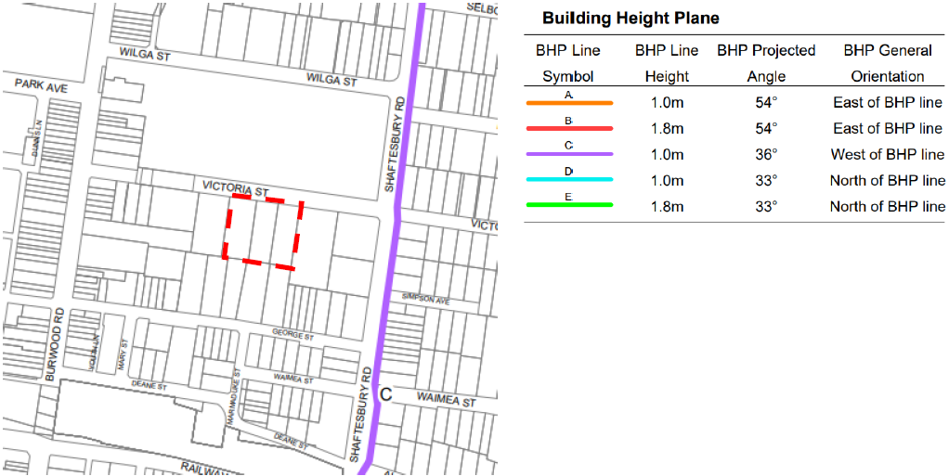

Figure 3: Extract from BLEP 2012 Building Height Plane Map, with site outlined in red

In light of the BHP prescribed pursuant to Clause 4.3A(2), the proposed height of 100.98m is compliant with the prescribed height limit for the site, as illustrated in Figure 4 below. This position is consistent with legal advice received by Council and the application of Clause 4.3A on other developments in the Burwood LGA.

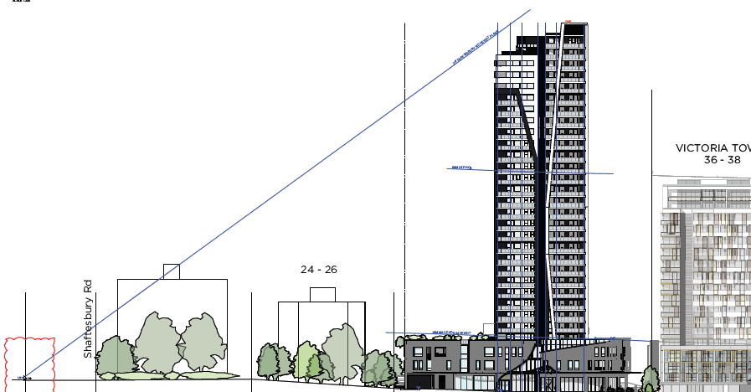

Figure 3: Victoria Street elevation showing the BHP line in relation to the proposed development

Notwithstanding that compliance with the BHP and thus the prescribed maximum height of the site has been demonstrated, for abundant caution the applicant has provided a Clause 4.6 variation request in relation to the 60m maximum height prescribed by Clause 4.3.

As set out in the variation request, the proposal exceeds the 60m height limit by 40.98m or 68.3%.

The submitted request presents an adequate justification that has regard to the objectives of the height limit standard in BLEP 2012, and the objectives of the B4 zone. It also addresses relevant case law concerning variations to development standards, whether non-compliance is reasonable and necessary in the circumstances of the case, the planning grounds to justify the contravention, and the public interest.

Public Art Strategy
Council adopted a Public Art Strategy on 30 October 2018. This strategy applies to development where the development cost is $40 million or more. The development is accompanied by a Capital Investment Value Report prepared by Construction Consultants (Registered Quantity Surveyor) dated 1 March 2019, which estimates the cost of development at $73,979,986. In this regard the Public Art Strategy applies to the proposed development.

Public art is being proposed within the development, but limited detail is provided in respect to the delivery timeframe, value or selection process of the public art. A condition of consent is recommended requiring a Public Art Plan to be provided consistent with the requirements of Council’s Public Art Strategy. The condition will require that the public art is installed prior to the occupation of the development.

Voluntary Planning Agreement (VPA)
Pursuant to Clause 4.4A of BLEP 2012, the subject site is prescribed an FSR of 4.95:1, subject to residential floor space not exceeding 70% of overall floor space and community infrastructure is provided as part of the development.

The proposal includes a maximum of 14,707m² (70%) of residential floor space. The applicant had initially proposed a tenancy on Level 2 of the development to be provided as community infrastructure on site. However, following discussions with Council officers during the assessment period, it was considered that a monetary contribution towards community infrastructure elsewhere in the Town Centre was a preferable option.

Consequently, a draft VPA was presented to and endorsed at a Council meeting on 28 July 2020. The draft VPA requires the developer to pay a monetary contribution of $3,337,775 to Council towards the provision of public facilities. A condition of consent requires the VPA to executed prior the issue of any Construction Certificate.

CONSULTATION
Internal Referrals
The application was referred to the following internal Council departments:

- Traffic Engineer; no objections, subject to conditions of consent.
- Heritage Advisor; no objections, subject to conditions of consent.
- Development Engineer; no objections, subject to conditions of consent.
- Tree Management Officer; no objections, subject to conditions of consent.
- Health and Environmental Services; no objections, subject to conditions of consent.

External Referrals
The following external referral comments were received:

- Transport for NSW (formerly RMS); no objections.

Neighbour notification

The proposed development was placed on Public Notification from 16 October 2019 until 8 November 2019. Five (5) submissions were received in response to the notification of the plans. The submission raised the following issues:

- Solar access to neighbouring properties;

Planner Comment: The proposed development will not have an unreasonable adverse impacts on solar access to neighbouring properties. The design of the proposal, comprising of a slender tower, reduces the overshadowing impact on neighbouring properties over and above a shorter, bulkier building by ensuring that shadows from the development ‘move’ quickly. As demonstrated in the accompanying shadow and solar points of view diagrams, there will be a varying degree of solar impacts on surrounding buildings, as discussed below.

Both Nos. 17 and 19 George Street comprise of residential flat buildings that are located southwards of the proposed development. However, due to the slender form of the proposed tower they will still receive acceptable levels of direct sunlight throughout the day, with the main effects of the proposal being after midday on 21 June.

East-facing apartments towards the south of “Victoria Towers” at No. 36-38 Victoria Street located to the west of the subject site will lose some direct sunlight at 9am on 21 June. However, the vast majority of east-facing apartments will receive direct sunlight at 9.30am and 10am, with a number also receiving direct sunlight at 11am. The apartments within the northern part of No. 36-38 will largely be unaffected by the proposed development.

The most affected neighbouring property will be No. 21 George Street directly to the south of the site. Some apartments in this property will receive direct sunlight at 9am, 12pm and 1pm on 21 June, however the majority of apartments will not receive 2 hours of direct sunlight. Nonetheless, given the town centre location and the controls that apply, encouraging high density development, this level of overshadowing is anticipated for proposed developments on the subject site. Further, it is considered that No. 21 will likely be redeveloped at some stage in the future given the increased density and height controls that also apply to that neighbouring site.

The development complies with the prescribed FSR and building height plane control, and complies with ADG setback requirements to all boundaries above podium level. As such, the level of overshadowing from the proposed development is considered to be reasonable and anticipated in this instance.

- Impact on views and privacy;

Planner Comment: The proposal generally complies with the ADG building separation requirements which seek to protect visual privacy, other than for minor non-compliances on the southern and eastern sides. These non-compliances are on lower levels and do not raise any adverse privacy impacts. There are limited across the subject site from neighbouring properties, with no significant views identified. Given that the proposed development complies with the FSR and height applicable to the site, and exceeds setback requirements above podium level, it is considered that any impacts on view sharing are reasonable.

- Traffic and parking impacts;

Planner Comment: Council’s Traffic Engineer and Transport for NSW have assessed the application and raises no objection to the proposal in terms of traffic and parking impacts, subject to conditions of consent.

- Lack of wind modelling;

Planner Comment: A Pedestrian Wind Comfort Study prepared by Synergetics accompanies the application. The report concludes that the development is not expected to cause unfavourable wind impacts in most circumstances.

- Acoustic and odour impacts from non-residential uses;

Planner Comment: A mixed use development of the density proposed is anticipated by the zoning and controls that apply to the site. An Acoustic Report accompanies the application and concludes that noise levels emitted from the operation of the proposed development are to comply with the relevant NSW guidance and noise criteria. Council’s Environmental Health unit have assessed the application and raise no objections in respect of noise or odour emissions, subject to conditions of consent.

Non-residential fitouts will be dealt with under separate application and will be assessed accordingly at the time to ensure that they do not give rise to adverse noise and odour impacts.

- Noise from demolition and construction;

Planner Comment: Standard conditions of consent will ensure that construction hours and operations comply with the relevant guidelines and thus, do not unduly impact neighbouring properties in terms of noise.

- Height proposed is excessive and well above 60m prescribed by Clause 4.3.

Planner Comment: The proposed height complies with the prescribed building height plane pursuant to Clause 4.3A of BLEP 2012.

The amended plans which are the subject of this report underwent public exhibition from 29 May 2020 until 15 June 2020. Four (4) further submissions including a petition with five (5) signatories were received in response to the notification of the plans. The submissions raised the following additional issues:

- Structural concerns due to the depth of foundations;

Planner Comment: The application is accompanied by a Geotechnical Report that outlines methods for excavation and foundations, including considerations of structural stability. Council’s Development Engineer has assessed the proposal and raises no objections to the proposed development, including excavation, subject to conditions of consent. This includes the requirement to undertake dilapidation reports for surrounding properties and public domain.

- Excessive density in Burwood;

Planner Comment: The subject site is located in a part of Burwood Town Centre which is planned to undergo a transition from medium density residential developments to a high density mixed use environment. Accordingly, density and height controls have been prescribed to the subject site to enable high density development, as proposed. The proposed development complies with the height and density controls that apply to the site.

- Lack of compatibility with Victoria Street;

Planner Comment: As this part of Burwood is currently undergoing transformation the streetscape of Victoria Street is changing. The proposed development is consistent with the emerging scale and character of the locality.

- Additional traffic issues from extra basement level.

Planner Comment: Council’s Traffic Engineer has raised no objection to traffic from the development in relation to the additional basement level.

CONCLUSION
The proposal (as amended) is for the construction of a 30 storey mixed use building containing 6,296m² of non-residential floor space and 179 residential apartments, 4 levels of basement car parking accommodating 316 vehicles and associated site landscaping, including pedestrian through site link at No. 28-34 Victoria Street, Burwood.
The proposal is consistent with the relevant planning instruments including SEPP 65, the Apartment Design Guide, Burwood LEP 2012 and Burwood DCP 2013. The development is permissible in the B4 zone and complies with floor space ratio and the building height plane development standards.
The proposed design provides a high quality development in the context of urban renewal and redevelopment for the area. The proposed development achieves good levels of internal amenity for future occupants, minimises adverse impacts on the amenity of neighbouring developments and will significantly enhance the appearance of the site and wider streetscape. The proposed apartments will have high levels of amenity and are oriented maximise solar access and cross ventilation.

The development is located in an area with excellent access to public transport, shopping, services and local recreation facilities. The incorporation of extensive non-residential floor space in the development with opportunities for outdoor dining will contribute to the vibrancy and vitality of the Burwood Town Centre. Further, the inclusion of a pedestrian through site in the development will increase activation at street level whilst improving pedestrian connectivity with the Burwood Town Centre.
Given the above, the proposal is recommended for approval.

RECOMMENDATION
That Development Application No. DA.2019.091 for the demolition of the existing structures and the construction of a 30 level mixed use development containing 179 residential units above basement parking and associated site landscaping at Nos. 28-34 Victoria Street, Burwood be approved, subject to the following conditions.
Conditions of Consent
Conditions of Approval

- The development to be carried out in accordance with following plans and documentation submitted to Council on as set out in the table below, except where amended by the other conditions of this consent.

Document | Author | Date/Received
Architectural Plan No’s:  DA-001 D  DA-102D; DA-103D;  DA-104D; DA-105D;  DA-106D; DA-107D;  DA-108D; DA-109D;  DA-110D; DA-111D;  DA-112D; DA-113D;  DA-114D; DA-115D;  DA-116D; DA-117D;  DA-118D; DA-119D;  DA-120D; DA-121D;  DA-122D; DA-123D;  DA-124D; DA-125D;  DA-126D; DA-127D;  DA-128D  DA-134D; DA-135D;  DA-136D  DA-201D; DA-202D;  DA-203D; DA-204D;  DA-205D  DA-301 D; DA-302 D;  DA-303 D; DA-304 D  DA-1401D; DA-1402D;  DA-1403D; DA-1404D;  DA-1405D; DA-1406D;  DA-1407D; DA-1408D | UrbanLink Pty Ltd | 12 August 2020
Survey Plan No. 12076-6 | Geometra Consulting | 21 April 2017
Stormwater Drainage Plans  Issue F – SW01; SW02; SW03; SW04; SW05; SW06; SW07; SW08; SW09; SW10; SW11; SW12; SW13 | ALPHA Engineering & Development | 18 September 2019
Landscape DA Report  Issue C | Tuft Design Studio | 28 July 2020
Capital Investment Value Report | Construction Consultants | 18 September 2019
Statement of Environmental Effects & Clause 4.6 Submissions | City Plan | September 2019
BASIX Certificate No. 1039439M | Greenworld Architectural Drafting | 17 September 2019
Heritage Impact Statement | Weir Phillips Heritage and Planning | August 2019
Traffic, Parking & RMS Matters | Varga Traffic Planning Pty Ltd | 8 April 2020
Crime Risk Report | City Plan | September 2019
Waste Management Plan | Dickens Solutions | September 2019
Traffic Impact Assessment | Road Delay Solutions | 23 September 2019
Acoustic Report | Acoustic Vibration & Noise Pty Ltd | 18 September 2019
Accessibility Report – Issue B | Access Link Consulting | 19 September 2019
BCA Compliance Assessment Report | Certified Building Specialists | 27 August 2019
Targeted Site Soil Assessment | FIMA | 28 May 2017
Geotechnical Desktop Study | STS GeoEnvironmental | April 2019
Aboricultural Impact Assessment | TALC | 16 August 2019

- The fees and/or bonds shown in the Table of Fees, are to be paid to Council or another approved collection agency (the Long Service Levy Corporation and its agents and an approved insurer under the Home Building Act 1989) and suitable evidence of payment is to be provided to the Principal Certifying Authority prior to the issuing of a Construction Certificate.

TABLE OF FEES

FEES/BONDS TO BE PAID TO COUNCIL OR TO THE NOMINATED BODY PRIOR TO ISSUING A CONSTRUCTION CERTIFICATE

- Building and Construction Industry Long Service Corporation levy $235,390.00 (Payment to be made to Council, the Corporation or its Agent)

- Damage Deposit - security deposit against damage occurring to Council's assets (footpath, road, stormwater drainage system, kerb and gutter, etc) during building work $48,300.00 (Payment to be made to Council as a bond prior to issue of a Construction Certificate and/or commencement of demolition/bulk excavation)

NOTE: This deposit is refundable if no damage occurs.

- Construction by the Applicant/Council the stormwater drainage works $7,755.00 (Payment to be made to Council as a bond) to be refunded upon satisfactory completion of works.

- Section 94A Contribution: $2,690,181.36. (Payment to be made to Council).

Note: the contribution amount will be adjusted at the time of payment. See Planning Condition 8 for more details.

- In accordance with Council’s Schedule of Fees and Charges (2020-2021) the applicant is required to pay a fee of $1,215.00 (including GST) for Council to supply, install and maintain a replacement tree of 100 litres container volume.

PLANNING

- Pursuant to Section 94A of the Environmental Planning and Assessment Act 1979 and the Section 94A Contributions Plan for the Burwood Local Government Area (Excluding Burwood Town Centre), the following monetary contribution towards public services and amenities is required:

Contribution Element |  |  | Contribution
A levy of 4% of the cost of carrying out the development, where the cost calculated and agreed by Council is $67,254,534.00 |  |  | $2,690,181.36
Index Period | June 2020 | CP₁ | 114.7
Office Use: T56

The above contribution will be adjusted at the time of payment. Applicants are advised to contact Council for the adjusted amount immediately prior to arranging payment.

The contribution will be adjusted in accordance with the following formula:

Contribution (at time of payment) = C x CPl₂
CPl₁
Where:

C: the original contributions amount as shown in the development consent
CPl₂ the Consumer Price Index: All Groups Index for Sydney, for the immediate past quarter (available from the Australian Bureau of Statistics at the time of payment)
CPl₁ the Consumer Price Index: All Groups Index for Sydney, applied at the time of granting the development consent as shown on the development consent.

Note: The minimum payment will not be less than the contribution amount stated on the consent.

The contribution is to be paid to Council, or evidence that payment has been made is to be submitted to the Principal Certifying Authority, prior to the issuing of a Construction Certificate.

Council may accept works in kind or other material public benefits in lieu of the contribution required by this condition subject to and in accordance with the requirements specified in the Section 94A Contributions Plan for the Burwood Local Government Area (Excluding Burwood Town Centre).

Note: Credit cards and personal cheques are not accepted for the payment of Section 94A Contributions in excess of $5,000.

- Glazed balcony balustrades shall be constructed of opaque materials in lieu of clear glazing.

- External gas water heaters are to be located in recessed enclosures within external walls and are to be located and are to be located so as to be not visible from a public road or place or adjoining property. Similarly, air conditioning units and plant are to be located so as not to be visible from a public road or place or adjoining property.

- A separate application shall be lodged for any proposed subdivision of the site. Such subdivision shall designate all car parking spaces attached to a lot with the exception of visitor parking which shall be designated as common property. No car parking spaces shall be created as a separate lot. The drainage system for the site including basement pit and pumps and on site detention shall be designated as common property.

- Lockable Mail boxes shall be provided at the residential access doors to the residential apartments lobby, such that mail can be delivered by Australia Post from outside the security door, and accessed by residents inside the secure area. The mail boxes are to comply with the requirements of Australia Post. Details to be submitted prior to the issue of a Construction Certificate for above ground works.

- Clothes drying areas or facilities shall be provided within an area of communal open space or provided within each residential unit. If provided on the balconies of individual units, the drying facilities must be screened from exterior view, and be designed in such a way that they do not detract from the building's appearance from the public domain.

- All doors leading from the exterior of the building to the residential apartment lobby are to be security grade fixtures and are to be appropriately security keyed to ensure the personal safety and security of residents of the development. The main entrance doors from the street are to include an intercom system linked to residential apartment as necessary. Details on these matters are to be submitted to the Principal Certifying Authority prior to the issue of a Construction Certificate for above ground works.

- The walkway along the northern side of the building adjacent to the retail tenancy at ground level which leads to the residential and commercial lobbies is to be provided with a security door or gate with controlled access that ensures the personal safety and security of the residents and users of the building. Details on these matters are to be submitted to Principal Certifying Authority prior to the issue of a Construction Certificate for above ground works.

- The entrance driveway for access to the basement parking levels is to be provided with a security door with controlled access that ensures the personal safety and security of the residents and users of the building. Design and Materials for the door need to be integrated with the overall facade design. The driveway security door is to be linked to the intercom system for each apartment. Details on these matters are to be submitted to Principal Certifying Authority prior to the issue of a Construction Certificate for above ground works.

- Access to and from the bin collection room is to be provided with a security door with controlled access that ensures the personal safety and security of the residents and users of the building. Design and Materials for the door need to be integrated with the overall fa9ade design. Details are to be submitted to Principal Certifying Authority prior to the issue of a Construction Certificate for above ground works.

- Adequate lighting is required to be provided for the following to ensure the safety and security of residents and users of the development to all access pathways leading to/from entrance and exit points of the buildings, bin collection points, external communal open space areas and driveways leading to the basement parking levels.

The installed lighting is to be of sufficient quality to ensure the effective operation of the CCTV system referred to in the following conditions. Details on all of these matters are to be submitted to Principal Certifying Authority prior to the issue of a Construction Certificate for above ground works.

- CCTV cameras shall be installed for the building so that they can survey the residential entrances and all external and internal access path ways, and the vehicular entrance to the driveway to the parking levels. The CCTV system shall provide a quality image that can assist with the detection of crime and be used by the NSW Police in any investigation (preferably a quality digital system). CCTV system footage shall be retained for a period of no less than fourteen days and be available upon request by the NSW Police when required. Details are to be submitted to Council's satisfaction prior to the issue of a Construction Certificate for above ground works.

- Provision of storage space in each unit and in the basement is to comply with the recommendations of the Apartment Design Guide. A schedule shall be submitted to the Principal Certifying Authority demonstrating compliance are to be submitted to Principal Certifying Authority prior to the issue of a Construction Certificate for above ground works.

- Provision of accessible/adaptable residential apartments and accessible parking spaces is to comply with the applicable Australian Standards as indicated in Section 3.2.19 of the Burwood Development Control Plan 2013.

- The Applicant is to consult with Ausgrid to determine the electrical supply need for the site including any requirement for an electricity substation prior to the issuing of a Construction Certificate and, if a site is required, it being situated adjacent to the street alignment, with the size and location of the area being in accordance with the requirements of this Council and Energy Australia, and the land required being dedicated without cost as a public roadway, to enable Energy Australia to establish the substation. The Linen Plan being registered with the Land Titles Office prior to the issue of an Occupation Certificate.

- All external lighting is to be designed and installed in a manner which prevents glare and/or spillage having an adverse impact on occupants of adjacent properties.

- Dilapidation surveys are to be carried out by a Practicing Structural Engineer, which is to include a full photographic record of the exterior and interior of the buildings at the applicants/owners expense on all premises adjoining the site and the survey is to be submitted to Council and the adjoining land owners prior to the commencement of any works. A further dilapidation survey is also to be carried out and submitted to Council and the adjoining owners prior to the issuing of an Occupation Certificate. The dilapidation surveys shall be dated accordingly.

- All hydrant booster pump and fire service equipment shall to be provided in accordance with the Building Code of Australia and housed within an enclosed cupboard of a design and finish that enhances the streetscape. Any booster room doors that front the street shall be flush with the frontage of the building and be designed of materials and colours that integrate with the building podium design. Details of these areas and the enclosures are to be assessed by an Accredited Fire Safety Engineer and shall comply with the performance requirements of the Building Code of Australia; shown on plans and submitted to the Principal Certifying Authority for approval prior to release of a Construction Certificate for the development.

HERITAGE

- A full schedule of all external materials (including samples of materials) shall be approved by Council's Heritage Officer’s prior to release of a Construction Certificate.

PUBLIC ART STRATEGY

- Public Art Strategy
  - The Development shall provide public art in accordance with Council’s Public Art Strategy.
  - The public art shall have a minimum value of $100,000 and the applicant is to consider the art being located in a public domain in consultation with Council’s Group Manager – Strategic Planning.
  - A Public Art Plan (PAP) shall be submitted to Council for approval prior to the issue of the Construction Certificate.

BUILDING

- Toilet facilities are to be provided, at or in the vicinity of the work site at the rate of one toilet for every 20 persons or part of 20 persons employed at the site. Each toilet provided:

- must be a standard flushing toilet, and
- must be connected
- to a public sewer, or
- to an approved chemical closet facility.

- The toilet facilities are to be completed before any other work is commenced.

- All excavations associated with the erection or demolition of the building are to be properly guarded and protected to prevent them from being dangerous to life or property.

- Where soil conditions require it:

  - retaining walls must be provided so as to prevent soil movement; and
  - adequate provision must be made for drainage.

- If an excavation associated with the erection or demolition of a building extends below the level of the base of the footings of a building on an adjoining allotment of land, the person causing the excavation to be made:

  - must preserve and protect the building from damage, and
  - if necessary, must underpin and support the building in an approved manner, and
  - must, at least 7 days before excavation below the level of the base of the footings of a building on an adjoining allotment of land, give notice of intention to do so to the owner of the adjoining allotment of land and furnish particulars of the excavation to the owner of the building being erected or demolished.

The owner of the adjoining allotment of land is not liable for any part of the cost of work carried out for the purposes of this condition, whether carried out on the allotment of land being excavated or on the adjoining allotment of land.

Allotment of land includes a public road and any other public place.
- If the work involved in the erection or demolition of a building:

  - is likely to cause pedestrian or vehicular traffic in a public place to be obstructed or rendered inconvenient, or
  - building involves the enclosure of a public place.

A hoarding or fence must be erected between the work site and the public place.

If necessary, an awning is to be erected, sufficient to prevent any substance from, or in connection with, the work falling into the public place.

The work site must be kept lit between sunset and sunrise if it is likely to be hazardous to persons in the public place.

Any such hoarding, fence or awning is to be removed when the work has been completed.

- Your attention is directed to the following:

WARNING

Utility Services

Before Construction - apply early as building of water and sewer services can be time consuming or may impact on other parts of your development.

Building Plan Approval

The plans approved by Council or the Principal Certifying Authority as part of the Construction Certificate for the development must also be approved by Sydney Water prior to excavation or construction works commencing. This allows Sydney Water to determine if sewer, water or stormwater mains or easements will be affected by any part of your development. Please go to http://www.sydneywater.com.au/tapin to apply.

- The builder is to take all precautions to ensure footpaths and roads are kept in a safe condition and to prevent damage to Council's property. Pedestrian access across the footpath must be maintained at all times. Any damage caused will be made good by Council at Council's restoration rates, at the builder's expense.

- No materials are to be stored on Council's roads, footpaths, nature strips or parks.

- No opening is to be made in any road or footpath, nor is any hoarding to be erected without the prior consent of Council. The builder is to obtain the relevant permit for which fees will be charged in accordance with Council's current Schedule of Fees and Charges.

- The builder shall erect and maintain in good order all necessary hoardings, barricades and warning signs required to provide adequate public safety. Night warning lamps are to be provided where necessary. A Principal Certifying Authority sign should also be displayed in a prominent position at the front of the development site.

- Hours of work shall be from 7:00am to 5:30pm Mondays to Fridays inclusive, and from 7:00am to 4:00pm Saturdays. No work shall be carried out on Sundays or Public Holidays. The owner/builder shall be responsible for the compliance of this condition by all sub-contractors, including demolishers.

- The approved structure shall not be used or occupied unless an Occupation Certificate (being a Final Certificate or an Interim Certificate) as referred to in section 109C(1)(c) of the Environmental Planning & Assessment Act 1979 has been issued.

(Vide Section 109M Environmental Planning & Assessment Act 1979)

- The building works are to be inspected during construction by the Principal Certifying Authority or an appropriate Accredited Certifier authorised by the Principal Certifying Authority at the stages of construction listed in the following schedule. The Principal Certifying Authority must be satisfied that the construction satisfies the standards specified in the Building Code of Australia or in this approval before proceeding beyond the relevant stage of construction.

SCHEDULE OF CONSTRUCTION STAGES REQUIRING INSPECTION

- After the commencement of the excavation for, and before the placement of, the first footing

- Prior to covering waterproofing in any wet areas, for a minimum of 10% of rooms with wet areas within a building

- Prior to covering any stormwater drainage connections; and

- After the building work has been completed and prior to any Occupation Certificate being issued in relation to the building.

- An application for a Construction Certificate is to be made to Council or an Accredited Certifier. Council's “Construction Certificate Application" form is to be used where application is made to Council. Copies are available upon request. A Construction Certificate must be obtained prior to the commencement of any building work.

- Dial Before You Dig is a free national community service designed to prevent damage and disruption to the vast pipe and cable networks which provides Australia with the essential services we use everyday - electricity, gas, communications and water.

Before you dig call "Dial Before You Dig" on 1100 (listen to the prompts) or register on line at www.1100.com.au for underground utility services information for any excavation areas.

The Dial Before You Dig service is also designed to protect Australia's excavators. Whether you are a backyard renovator, an individual tradesman or a professional excavator, the potential for injury, personal liability and even death exists everyday. Obtaining accurate information about your work site significantly minimises these risks.

Reason: To ensure that essential services such as electricity, gas, communications and water are not affected by excavation or construction works.

- All building works being erected wholly within the boundaries of the property.

- All sanitary plumbing being concealed in suitably enclosed ducts. Such ducts are to be constructed internally (i.e. not on the outside face of an external wall) and are to be adequately sound-proofed.

- All plumbing and drainage work being carried out by licensed tradesmen and in accordance with the requirements of the Plumbing Code of Australia.

- The floor of the wet areas being of a material impervious to moisture and graded and drained to the sewers of Sydney Water.

- The noise emitted by any air-conditioning equipment being inaudible in your neighbours' homes between 10:00pm and 7:00am weekdays and 10:00pm and 8:00am on weekends and public holidays. Council is to be consulted prior to the installation of any air-conditioning equipment.

- All building work must be carried out in accordance with the provisions of the Building Code of Australia .

- Safety glazing complying with 81.4 of the Building Code of Australia used in every glazed door or panel that is capable of being mistaken for a doorway or unimpeded path of travel. The glazing must comply with Australian Standard AS 1288-2006: Glass in Buildings - Selection and Installation. Details of the method of complying with this requirement must be noted on the plans or in the specifications and provided to the Principal Certifying Authority prior to the issuing of a Construction Certificate for above ground works.

- Framed panels or doors enclosing or partially enclosing a shower or bath shall be glazed with "A" or "B" grade safety glazing material in accordance with Australian Standard AS 1288-2006, Table 4.5 SAA Glass Installation Code (Human Impact Considerations) and 81.4 of the Building Code of Australia. Details of the method of complying with this requirement must be noted on the plans or in the specifications and provided to the Principal Certifying Authority prior to the issuing of a Construction Certificate for above ground works.

- Dividing Fences Act 1991 - Your attention is directed to any obligations or responsibilities under the Dividing Fences Act 1991 in respect of adjoining property owner/s which may arise from this application. Any enquiries in this regard may be made to the Crown Lands Division on (02) 8836 5332.

- A registered surveyor's certificate being submitted to the Principal Certifying Authority, prior to the issue of an Occupation Certificate, as follows:

  - Before pouring of concrete slab on every level to indicate the height of the finished floor level and to show boundary clearances; and
  - On completion of the building to indicate the height of the finished floor levels, the height of the roof ridge/parapet and to show boundary clearances and areas of the site occupied by the building.

- Prior to the commencement of building work, the following is to be carried out:

  - Submit to Council a "Notice of Intention to Commence Building Work and Appointment of a Principal Certifying Authority" form. Council's "Notice of Intention to Commence Building Work and Appointment of a Principal Certifying Authority" form is to be used where application is made to Council.
  - Ensure detailed plans and specifications of the building are endorsed with a Construction Certificate by Council or an Accredited Certifier. Council's "Construction Certificate Application" form is to be used where application is made to Council. Copies are available on request.

(Vide Section 81A Environmental Planning & Assessment Act 1979)

- The building being known as No. 12-14 Gloucester Avenue, Burwood and this number (at least 150mm in height) being clearly displayed on the site prior to the issuing of an Occupation Certificate.

- Utility Services

Before Construction - apply early as building of water and sewer services can be time consuming or may impact on other parts of your development.
Section 73 Compliance Certificate

A compliance certificate must be obtained from Sydney Water, under Section 73 of the Sydney Water Act 1994. Our assessment will determine the availability of water and sewer services, which may require extension, adjustment or connection to our mains. A Section 73 Compliance Certificate must be completed before an occupation certificate will be issued. Sydney Water will assess the development and if required will issue a Notice of Requirements letter detailing all requirements that must be met. Applications can be made either directly to Sydney Water or through a Sydney Water accredited Water Servicing Coordinator (WSC).

Go to http://www.sydneywater.com.au/section73 or call 1300 082 746 to learn more about applying through an authorised WSC or Sydney Water.

- Structural engineer's details prepared and certified by a practicing Structural Engineer for all reinforced concrete and structural members being submitted to the Principal Certifying Authority for approval prior to the issuing of a Construction Certificate.

- The Principal Certifying Authority or Structural Engineer is to also supervise the construction. All Certificates from the supervising Structural Engineer are to be submitted to the Principal Certifying Authority before an Occupation Certificate is issued stating that all reinforced concrete and/or structural members have been erected in accordance with his/her requirements and the relevant SAA Codes.
- Timber sizes and the framework in general are to conform with the requirements of Australian Standard AS 1684 "Residential timber-framed construction."

- Mechanical ventilation/air conditioning details are to be submitted to the Principal Certifying Authority for approval prior to the issuing of a Construction Certificate and must include the following:-

  - The location and size of proposed ductwork.
  - The location of individual air handling units away from the public domain view.
  - The location of equipment.
  - The performance characteristics of the proposed motor/s and fan/s.
  - The air flow characteristics of the system.

At the completion of work a Certificate from an Accredited Certifier, Mechanical Engineer or other suitably qualified person, to the effect that the ventilation system has been installed and performs in accordance with the provisions of Part F4 of the Building Code of Australia, Australian Standard AS 1668 "SAA Mechanical Ventilation and Air Conditioning Code", Part 1 and Part 2, Australian Standard AS 3666-1989 and the Noise Control Act 1975, must be submitted to the Principal Certifying Authority prior to the issue of an Occupation Certificate.

- Fire Resistance Levels of all structural members, including external and internal walls, spandrels, external and internal columns, lift shafts and stair shafts, ventilation, pipe and like shafts, floors and roofs shall comply with the requirements of Specification C1.1 of the Building Code of Australia. Details of the method of achieving this must be noted on the plans or in the specifications prior to the issuing of a Construction Certificate.

- All materials used in the building must comply with early fire hazard criteria of Specification C1.10 of the Building Code of Australia.

- Means of access and egress complying with Section D of the Building Code of Australia. Details of the method of achieving this must be noted on the plans or in the specifications prior to the issuing of a Construction Certificate.

- The building being provided with both access and sanitary facilities (where required) for people with disabilities. The sanitary facilities are to be provided in accordance with F2.4 of the Building Code of Australia and are to comply with the requirements of Clause 10 of AS 1428.1-2009. Access is to be provided to and within the building so as to comply with all the requirements of Part D3 of the BCA and the relevant provisions of AS 1428.1-2009. Details of the method of achieving this must be noted on the plans or in the specifications provided to the Principal Certifying Authority prior to the issuing of a Construction Certificate for above ground works.

- The Commonwealth Disability Discrimination Act 1992 may apply to this particular proposal. Submissions and/or approval of the application does not imply or confer compliance with this Act. Applicants should satisfy themselves and make their inquiries to the Human Rights and Equal Opportunity Commission.

- Continuous balustrades shall be provided along the side/s of any stairway or ramp, any corridor, hallway, balcony, access bridge or the like, any path of access to a building if:-

  - It is not bounded by a wall, and
  - The change in level is more than one (1) metre, or five (5) risers in the case of a stairway, from the floor or ground surface beneath,
  - except where specific exemptions are provided in the Building Code of Australia.

Balustrades shall prevent as far as practicable:

- Children climbing over or through it, and
- Persons accidentally falling from the floor, and
- Objects which might strike a person at a lower level falling from the floor surface.

Balustrade heights and designs shall comply with Part D2.16 of the Building Code of Australia and Australian Standard AS/NZS 1170 Part 1 - Structural design actions. Height above nosings of stair treads, landing, corridors and the like shall generally be not less than 865mm.

Details of the method of satisfying these requirements must be noted on the plans or in the specifications prior to the issuing of a Construction Certificate.

- The building being equipped with a smoke alarm system as required by Table E2.2a of the Building Code of Australia. The system is to satisfy the requirements of Specification E2.2a of the Building Code of Australia and in particular is to comply with the relevant parts of AS 3786-2014 and AS 1670.1-2004. Details of the method of complying with this requirement must be noted on the plans or in the specifications prior to the issuing of a Construction Certificate.

- Protection of openable windows (where required) is to be in accordance with Part D2.24 of the Building Code of Australia. Details of the method of satisfying this requirement must be noted on the plans or in the specifications prior to the issuing of a Construction Certificate for above ground works.

- A Fire Safety Certificate (copies available from Council) is to be given to the Principal Certifying Authority prior to applying for an Occupation Certificate or Interim Occupation Certificate and thereafter once in every 12 month period an Annual Fire Safety Statement is to be given to Council. The certificate and statement attest to both the inspection of all essential fire safety measures by a properly qualified person and to the regular maintenance of the fire safety measures. A copy of the Fire Safety Certificate and the Fire Safety Schedule are to be given to the Commissioner of New South Wales Fire and Rescue by the building owner and copies of these documents are to be prominently displayed in the building. Similarly copies of Annual Fire Safety Statements are also to be given to the Commissioner and displayed in the building.

(Vide clause 153 & Division 3 of the Environmental Planning & Assessment Regulation 2000)

- Noise transmission and insulation ratings for building elements being in accordance with Specification Part FS of the Building Code of Australia.

Details of the method of satisfying this requirement must be noted on the plans or in the specifications prior to the issuing of a Construction Certificate.

- Engineering Design - Basement Excavation

The following engineering details or design documentation shall be submitted to the Principal Certifying Authority (Council or Accredited Certifier) prior to the issuing of a Construction Certificate:

  - Documentary evidence prepared by a suitably qualified professional Geotechnical Engineer that confirms the suitability of the site for the proposed excavation and building, as well as certifying the suitability and adequacy of the proposed design and construction of the building for the site.

  - A report shall be prepared by a professional engineer prior to the issuing of a Construction Certificate, detailing the proposed methods of excavation, shoring or pile construction including details of vibration emissions and detailing any possible damage which may occur to adjoining or nearby premises due to building and excavation works. Any practices or procedures specified in the Engineer's Report in relation to the avoidance or minimisation of structural damage to nearby premises, are to be fully complied with and incorporated into the plans and specifications for the Construction Certificate.

A copy of the Engineer's Report is to be submitted to Council, even if the Council is not the Principal Certifying Authority.

DEMOLITION

- Removal of any asbestos must be undertaken in compliance with the requirements of SafeWork NSW. Refer to their Code of Practice "How to Safely Remove Asbestos" dated September 2016.

- Demolition of the building is to be carried out in accordance with the requirements of Australian Standard AS 2601 - 2001, where applicable.

- Hours of demolition work shall be from 7:00am to 5:30pm Mondays to Fridays inclusive, and from 7:00am to 4:00pm Saturdays. No demolition work shall be carried out on Sundays or Public Holidays. The owner/builder shall be responsible for the compliance of this condition by all sub-contractors, including demolishers.

- Access to the site is to be restricted and the site is to be secured when demolition work is not in progress or the site is otherwise occupied.

- The demolition site is to be provided with measures to mitigate against dust nuisances arising on adjoining sites and roadways. To achieve this, a fence or barrier is to be erected around the site. The construction may be steel mesh which is covered with a suitable filtering medium or such other construction acceptable to Council. An effective program of watering the site is also required to be maintained.

- All demolition, excavation and construction materials are to be removed from the site or disposed of on-site using methods that comply with relevant environmental protection legislation. When demolition of any existing building is involved, burning of any demolition materials on the site is prohibited.

- Dilapidation surveys are to be carried out by a Practicing Structural Engineer, which is to include a full photographic record of the exterior and interior of the buildings at the applicants/owners expense on all premises adjoining the site excluding the northern tower on Elsie St and the survey is to be submitted to Council and the adjoining land owners prior to the commencement of any works.

- The applicant shall take all necessary precautions to adequately protect adjoining properties during demolition. This shall include the submission to the Principal Certifying Authority of specific details of the protection to be employed prior to demolition commencing.

HEALTH

Land Contamination

- Any soils or materials requiring removal from the site as part of the site excavation are to be classified in accordance with the ‘Waste Classification Guidelines, Part 1: Classifying Waste’ NSW EPA (2014)

Environmental Management

- An Environmental Management Plan is to be submitted to Council for approval, prior to the commencement of any works, detailing the control and management methods to be implemented in addressing the following issues during the demolition, excavation and construction phases of the project:

- Noise and vibration control
- Dust and odour suppression and control
- Storm water control and discharge
- Erosion control
- Waste storage and recycling control
- Litter control
- Construction material storage
- Truck cleaning methods on site so as to prevent spread of soil and like materials onto Council's roadways

- The use of the premises, building services, equipment, machinery and ancillary fittings shall not give rise to “offensive noise” as defined under the provision of the Protection of the Environment Operation Act 1997. The sound level output shall not exceed 5 dB(A) above the ambient background level at the received boundary.

- Mechanical ventilation and or air conditioning systems and equipment are to be designed and installed in locations that do not cause any visual impacts from the public domain, noise nuisance or disturbance to near-by residential or commercial premises. Details of the type of equipment locations and any noise attenuation treatment are to be submitted to Principal Certifying Authority prior to the issue of the Construction Certificate.

- The construction of windows / sliders, doors, external walls and roofs are to be comply with the recommendations listed in Part 5 of the Acoustic Assessment prepared by Acoustic, Vibration and Noise Pty Ltd (ref: 2019-096) dated 18 September 2019 in order to achieve the required noise reduction targets and levels as required by AS 2107 ‘Acoustics- Recommended Design Sound Levels and Reverberation Times’ and Clause 102 of the SEPP. Certification as to the compliance of the acoustic treatments are to be submitted to the Principle Certifying Authority prior to the issue of an Occupation Certificate.

WASTE MANAGEMENT

- The waste management for the development shall be carried out as specified in the Waste Management Plan prepared by Dickens Solutions ‘Proposed Mixed Use Residential & Commercial Development @ 28-34 Victoria Street Burwood’ dated September 2019.

- A waste cupboard or other storage area is to be provided within each dwelling which is of sufficient size to hold a single day’s waste and to enable source separation of general waste, recyclables and compostable materials.

- A separate area is to be provided within the development (minimum 15 square metres) for the temporary storage of unwanted large bulky house hold items (clean up material) awaiting disposal either privately or through Councils clean up service.

- Both residential and commercial garbage and recycling storage areas are to be:

  - Supplied with both hot and cold water;
  - Paved with impervious floor materials;
  - Coved at the intersection of the floor and the walls;
  - Graded and drained to a floor waste which is connected to the sewer in accordance with the requirements of Sydney Water;
  - Adequately ventilated (mechanically or naturally) so that odour emissions do not cause offensive odour as defined by the Protection of the Environment Operations Act 1997;
  - Fitted with appropriate interventions to meet fire safety standards in accordance with the Building Code of Australia.
  - Suitable signage is to be installed in each waste service room encouraging the separation of recyclables from the general waste stream.

- Manufactures details and specifications for the installation, fire suppression and health and odour control measures for the garbage chute are to be submitted to Council for approval prior to the issue of the Construction Certificate.

- Certification is to be provided by the installer of the chute system prior to the issue of an occupation certificate certifying that the Chute has been installed in accordance with the manufacturer’s specification.

- Suitable signage is to be installed in each level of the chute waste service rooms encouraging the separation of recyclables from the general waste stream.

- A Caretaker is to be appointed for the development who will have ongoing responsibility for the proper management of the waste and recycling services.

- All waste collections are to be carried out from within the building (not from the kerb side). The caretaker is to wheel the waste and recycling bins to the nominated bin holding area for collection.

- All waste collections are to be carried out in the nominated ground floor area on site. The driveway shall be designed to enable a fully laden heavy rigid waste vehicle to access the basement area in a forward direction, access and empty the bins and exit the site in a forward direction.

- Prior to the issue of an Occupation Certificate, the applicant shall provide to Council a legally drafted agreement at their own expense in the form approved by Council which gives right of access and absolves Council and / or any of its waste collection contractors from any damage or injury that may arise from the onsite collection of waste and recyclables.

- Residential and commercial waste and recycling collections are to be carried out in a manner and at times which do not cause a noise nuisance to the immediate or nearby residents.

Note; Council reserves the right to issue a direction under the Protection of the Environment Operations Act to address any noise or other nuisance complaints.

- Waste and recycling bins shall be kept clean and hygienic condition. Bins are to be washed regularly within the garbage storage room with any waste water being discharged to the sewer by way of a grated drain.

- Prior to the issue of an Occupation Certificate, the applicant is to arrange with Council’s Environment and Health Section the issue of the appropriate number of garbage and recycling bins for the residential portion of the development and payment of the necessary fees to enable commencement of the waste and recycling services.

- The owner/occupier of the premises is to enter an agreement with registered waste company or provider for the regular collection of all commercial waste and recyclable material generated from the premises. A copy of the agreement is to be retained on site and produced to an authorized Council officer upon request.

ENGINEERING - GENERAL

- All activities and works external to the site, or that affect public roads, are to be carried out in accordance with Council's Policies including but not limited to the Works on Council's Road Reserve Assets Policy, Rubbish Skips Policy, Work Zone Policy and Temporary Road Closure (Including Standing Plant) Policy.

- A road-opening permit shall be obtained for all works carried out on public or Council controlled lands. Restoration of landscaping, roads and paths shall be carried out by Council at the applicant's expense in accordance with Council's Schedule of Fees and Charges. The applicant or any contractors carrying out works in public or Council controlled lands shall have public liability insurance cover to the value of $20 million, and shall provide proof of such cover to the Principal Certifying Authority prior to carrying out the works. Please see Burwood Council's web site www.burwood.nsw.gov.au - Go to Development/Working on Footpaths or Roadways?/Works on Council Property (Application Form).

- Spoil and building materials shall not be placed, stored, thrown or caused to fall on any public roadway or footpath. Waste containers shall be placed in accordance with Council's Rubbish Skips Policy. Contact Council for a list of approved skip bin suppliers.

- The builder is to ensure footpaths and roads affected by construction works are kept safe and prevent any damage to Council property. The builder shall erect and maintain where necessary approved hoardings, barricades, warning signs and night warning lamps to ensure public safety. Pedestrian access across the footpath must be maintained at all times.

- The following matters shall apply to the damage deposit listed in the Table of Fees:

  - This deposit is refundable if no damage occurs. Any damage caused will be repaired at Council's restoration rates, at the applicant's expense. All or part of the deposit will be forfeited to cover damage to Council's property during the course of demolition and/or construction.

  - Council will carry out two inspections of the Council's footpath, kerb and gutter, stormwater drainage system and roadway, prior to works commencing and at the completion of all work covered by this consent. Council is aware that damage may be caused by individual contractors that culminate in the damage inspected at Council's final inspection. The applicant is responsible for attributing any part of the damage to their individual contractors. Council will not refund any part of a damage deposit until the completion of the work covered by this consent.

- The following matters apply to the construction of the proposed vehicular crossing listed in the Table of Fees:

  - A vehicular crossing 6m wide on Victoria Street shall be constructed by the Applicant/Council at the applicant's cost.
  - The driveway shall be 1m clear of any pits, lintels, poles and 2m clear of trees in the road reserve.
  - All redundant vehicular crossings shall be removed and replaced with kerb and gutter and footpath at no cost to Council.

- Internal driveway levels shall be designed and constructed to conform with existing footpath and road profiles such that vehicles are not damaged while accessing the property. Council footpath and road profiles will not be altered for this purpose.

- Stormwater from all roof and paved surfaces shall be collected and discharged by means of a gravity pipe to Council's street drainage system. . A new Council standard stormwater pit and 1.8m kerb inlet lintel shall be constructed at the property frontage to connect stormwater to Council’s underground drainage system.

- The applicant is to have prepared a longitudinal section of the proposed vehicular ramp access, drawn at 1:25 natural scale.

- The longitudinal section shall be prepared by a competent practicing civil engineer in accordance with AS 2890.1.

- The design is to be reviewed by Council or an Accredited Certifier - Civil Engineering prior to the issuing of a Construction Certificate.

- Temporary measures shall be provided during demolition, excavation and/or construction to prevent sediment and polluted waters discharging from the site.

- An Erosion and Sediment Control Plan (ESCP) is to be prepared by a competent practicing hydraulic/civil engineer in accordance with the publication “Managing Urban Stormwater: Soils & Construction” (Landcom, 2004) and Supplement 10 of Council's Stormwater Management Code prior to the commencement of any demolition, excavation or construction works upon the site. All relevant erosion and sediment control measures identified in the ESCP must be implemented during and throughout the entire works to prevent sediment and polluted waters discharging from the site.

- The ESCP drawing no.A9083-SW01– F prepared by Alpha Engineering is not adequate. The plan shall be revised/ updated to provide all the required facilities of carrying out a deep excavation. The plan shall provide probable dewatering arrangement, filtration pond including truck washing, wheel cleaning etc. in order to ensure that Council’s road stays clean at all times from mud and sediment.

- The erosion and sediment control plan is to be reviewed by Council prior to the issuing of a Construction Certificate.

- All demolition and excavation materials are to be removed from the site or disposed off-site using methods that comply with relevant environmental protection legislation.

- Vehicles removing demolished materials from the site shall access and depart from the site through Burwood Road and Liverpool Road. Vehicles involved in removing materials from the site shall be limited to an 8 tonne gross weight per axle.

- Bulk Earthwork and Shoring

  - No opening is to be made in any road or footpath, nor is any hoarding to be erected without the prior consent of Council. The builder is to obtain the relevant permit for which fees will be charged in accordance with Council's Schedule of Fees and Charges.

  - The builder shall erect and maintain in good order all necessary hoardings, barricades and warning signs required to provide adequate public safety. Night warning lamps are to be provided where necessary.

  - Public roads to be kept clean and free of any material which may fall from vehicles or plant. Waste containers shall be placed in accordance with Council's Code for Activities Affecting Roads and are subject to the payment of appropriate fees.

  - Heavy vehicles entering and leaving the site must only cross the footpath where it is adequately timbered and strapped. Pedestrian access across this footpath must be maintained in good order at all times during the excavation work.

  - The contractor shall strictly implement all erosion and sediment control (ESCP) measures prior to the commencement of excavation. Such measures shall be inspected at site by a competent practicing hydraulic/civil engineer and the PCA shall be provided with a compliance certificate that all the ESCP measures have been implemented.

  - The Applicant shall prepare detailed survey reports of all existing service authority assets in and around the site of the proposed development that may be affected in any way by the proposed excavation. Surveys should include, but not be limited to, high and low voltage electricity, water, stormwater, sewer, gas, telecommunications, street lighting and drainage assets, etc.

  - The Applicant shall liaise with all relevant service authorities (including, but not limited to electricity, water, stormwater, sewer, gas, telecommunications, street lighting and drainage) to develop final designs that satisfy all requirements of the service authority providers in respect of protection, termination or relocation of existing assets, temporary access and future permanent access for maintenance of assets.

  - The Applicant shall prepare detailed method statements to demonstrate how the proposed excavation is to be conducted such that all relevant utility authority assets are protected and maintained throughout the construction stage of the development, or are relocated. Method statements are to be submitted to the relevant utility authorities for their written approval.

- Installation of Temporary Ground Anchors:
Where the applicant requires the use of temporary ground anchors to shore the bulk excavation within public roads an NPER Registered Structural Engineer’s certificate along with certified plans showing the details and extent of work shall be submitted to Council. The following conditions shall be addressed by the Applicant.

  - The Applicant is required to obtain a ‘Temporary Ground Anchor Permit’ from Council for which an ‘Application for Works on Council’s Property’ shall be lodged in Council. Subject to the application being approved by Council, the applicant shall pay Council calculated Anchor Fees and the ‘Refundable Deposit’ as required under Council’s Statement of Revenue Policy 2019 – 2020. Payment of the ‘Refundable Deposit’ can be made in the form of a Bank Guarantee.

NOTE: This deposit is refundable if no damage occurs.

  - The contractor shall be responsible to obtain and submit to Council a written authority from all public utility authorities that they have no objection in regards to the installation of temporary ground anchors, prior to works commencing.

  - The contractor shall be responsible to obtain permission from the neighbours of the adjoining properties prior to installation of anchors.

  - The contractor shall be responsible for any injury or damage either to persons or property due to the presence or failure of the supporting structure on the public way and the contractor shall indemnify the Council against all claims that may arise from the installation of the supporting structure. In this regard the contractor shall provide written evidence of public liability insurance cover to the minimum value of $20 million, with Council named in the insurance policy, prior to work commencing.

  - The anchors shall be installed in accordance with the manufacturer’s instructions.

  - The construction of ground anchors shall be of a temporary nature only and a written undertaking shall be given that the ground anchors are temporary only and shall be de-stressed after final lateral supports are in place. The written undertaking is to be provided to Council, prior to work commencing.

  - Council may unilaterally use the damage deposit for the demolition and removal of the shoring elements constructed within the public road including the repair/reconstruction of any other associated damage to Councils infrastructure, it be necessary due to non-compliance with these conditions.

  - All shoring with the exception of the released temporary ground anchors shall be completely removed from the public road to a depth of 2.5m on completion. The void shall be backfilled by suitable materials and compacted.

  - All shoring including ground anchors are to be certified by a practicing professional structural engineer. Certification is required as follows:

- That the proposed shoring and anchor scheme is capable of supporting the public road, to be submitted prior to work commencing.
- Certification that the shoring and anchor scheme has been adequately constructed, following installation.
- Final certification that the anchors have been de-stressed and all shoring with the exception of the anchors have been removed to a depth of 2.5m, on completion following de-stressing of the anchors. This certificate is mandatory prior to release of the Anchor bond.

  - Council’s footpath and roadway are to be kept safe for the passage of motorists and pedestrians at all times. Closure of any part of the public thoroughfare shall only be carried out with the approval of Council’s Traffic Engineer.

  - All stockpiled shoring materials and equipment shall be kept solely within the private property and not obstruct the footpath or roadway at any time.

  - All earth and rock anchors shall be released before the completion of building work.

STORMWATER DRAINAGE

- A detailed drainage design shall be submitted to the Principal Certifying Authority.

  - The design and calculations shall indicate the details of the proposed method of stormwater disposal and shall be prepared by a competent practicing hydraulic/civil engineer in accordance with Council's Stormwater Management Code.

  - Allowance shall be made for surface runoff from adjacent properties, and to retain existing surface flow path systems through the site. Any redirection or treatment of these flows shall not adversely affect any other property.

  - Overflow paths shall be provided to allow for flows in excess of the capacity of the pipe/drainage system draining the site, as well as from any on-site stormwater detention storage.

  - The design is to be reviewed by Council or an Accredited Certifier - Civil Engineering prior to the issuing of a Construction Certificate.

- Water Quality Requirement: The following stormwater quality targets for post development shall be adopted in accordance with modeling guideline developed by Sydney Metropolitan Catchment Management Authority (CMA).

- 90% reduction in the post development Average Annual Gross Pollutant load (greater than 5mm)
- 85% reduction in the post development Mean Annual Load of Total Suspended Solids (TSS)
- 65% reduction in the post development Mean Annual Load of Total Phosphorus (TP)
- 45% reduction in the post development Mean Annual Load of Total Nitrogen (TN)

Water Quality requirements should be determined by modelling of the proposed development to meet the quality targets. Computer models like MUSIC (the Model for Urban Stormwater Improvement Conceptualisation) can be used to present default and proposed water quality parameters.

- Details and calculations shall be prepared by a competent practicing Hydraulic/Civil Engineer.
They shall include:

  - a catchment plan

  - plans showing proposed and existing floor, ground and pavement levels to Australian Height Datum (AHD)

  - details of pipelines/channels showing calculated flows, velocity, size, materials, grade, invert and surface levels

  - details and dimensions of pits and drainage structures

  - hydrologic and hydraulic calculations

  - details of any services near to or affected by any proposed drainage line

  - any calculations necessary to demonstrate the functioning of any proposed drainage facility is in accordance with Council's requirements

  - the depth and location of any existing stormwater pipeline and/or channel being connected to shall be confirmed by the applicant on site. Certification of such is to be provided to Council prior to the release of the construction certificate.

The details and calculations are to be reviewed by Council or an Accredited Certifier - Civil Engineering, prior to the issuing of a Construction Certificate.

- The stormwater drainage plan, drawing no. A9083-SW13 – Rev. F prepared by Alpha Engineering and Development shall be revised to address the following:

- The orifice designed and provided only for 5 years ARI is not adequate. The DCP shall be provided with orifices to control outflows for 2, 10 and 100 year ARI
- The invert of the proposed new pit shall be confirmed as per the Council’s existing pipe on Victoria Street.
- The revised drawing shall be reviewed by Council or an Accredited Certifier - Civil Engineering, prior to the issuing of a Construction Certificate.

- The following matters shall apply to work out the stormwater drainage bond listed in the table of Fees.

  - A new Council standard pit and 1.8m lintel shall be constructed on Victoria Street on the property frontage for the property’s stormwater to connect to. Pipes laid under road surface connecting to Council’s pit shall be RCP Class 4.

  - Long section of the Ø300 mm pipe, details of the connecting pits together with the invert levels, surface levels etc. shall be provided. Minimum 500mm pipe cover shall be maintained under road surface at all times.

  - The depth and location of any services within the area that would be affected by the connection of the stormwater pipe (i.e. gas, water, sewer, electricity, telephone, traffic lights etc.) shall be confirmed by the applicant on site and are to be included on the design drawings. Any adjustment required will be at the applicant’s expense.

  - The stormwater works described above shall be constructed at applicant’s expense. The bond as listed in the Table of Fees shall be refunded after completion of the stormwater works described above as per Council’s satisfaction.

- The stormwater works on the development property and connection to Council's stormwater system are to be inspected during construction by a competent practicing hydraulic/civil engineer. The inspections are to be carried out at the stages of construction listed in the following schedule. A compliance Certificate verifying that the construction is in accordance with the approved design, this development consent and satisfies the relevant Australian Standard is to be submitted to the Principal Certifying Authority before proceeding beyond the relevant stage of construction.

SCHEDULE OF CONSTRUCTION STAGES REQUIRING INSPECTION

- Following placement of pipe bedding material. Confirm trench/pipe location, adequacy of depth of cover, bedding material and depth.

- Following joining of pipes and connection to Council's stormwater system.

- For on-site detention systems:-

(i) Following set out of detention tank/area to confirm area and volume of storage.

  - Following placement of weep-holes, orifice and/or weir flow control, outlet screen and overflow provision.

- Following backfilling. Confirm adequacy of backfilling material and compaction.

- Following completion of all drainage works:-

  - Works-as-executed (WAE) plans, shall be prepared and signed by a registered surveyor. These plans shall include levels and location for all drainage structures and works, buildings (including floor levels) and finished ground and pavement surface levels. These plans are to be reviewed by the competent practicing hydraulic/civil engineer that inspected the works during construction.

  - The Principal Certifying Authority is to be provided with a Certificate from a competent practicing hydraulic/civil engineer. The Certificate shall state that all stormwater drainage and related work has been constructed in accordance with the approved plans and consent conditions as shown on the work-as-executed plans, prior to the issuing of an Occupation Certificate.

- Grated drains shall be provided along the property boundary at the vehicular crossings and are to connect to the internal drainage system. The Principal Certifying Authority is to be provided with a Certificate from a competent practicing hydraulic/civil engineer. The Certificate shall state that the grated drains have been constructed in accordance with the approved plans and this consent condition as shown on the work-as-executed plans, prior to the issuing of an Occupation Certificate.

- A Positive Covenant under section 88E of the Conveyancing Act shall be created on the title of the property(s) detailing the

i) Overland surface flow path
ii) On-site Stormwater Detention system
iii) Pump and rising main system

incorporated in the development. The wording of the Instrument shall include but not be limited to the following:

- The proprietor of the property agrees to be responsible for keeping clear and the maintenance of the facilities consisting of:

  - The overland surface flow path
  - On-site Stormwater Detention system
  - Pump and rising main system

- The proprietor agrees to have the facilities inspected annually by a competent practicing Hydraulic/Civil Engineer.

- The Council shall have the right to enter upon the land referred to above, at all reasonable times to inspect, construct, install, clean repair and maintain in good working order the facilities in or upon the said land; and recover the costs of any such works from the proprietor.

- The registered proprietor shall indemnify the Council and any adjoining land owners against damage to their land arising from failure of any component of the facilities.

The applicant shall bear all costs associated with the preparation of the 88E Instrument. The wording of the Instrument shall be submitted to, and approved by Council prior to lodgement at the Land and Registry Services (LRS). Evidence that the Instrument has been registered at the LRS shall be submitted to Council, prior to issuing of an Occupation Certificate.

- The northern boundary fences shall be constructed in materials that allow unobstructed passage of surface stormwater flows. Fencing details shall be submitted to Council or an Accredited Certifier - Civil Engineering, prior to the issuing of a Construction Certificate.

- The pump system is only permitted for the drainage of the basement areas where the finished slab is below the ground level. The following conditions are to be satisfied:

- A pump and rising main design shall be submitted to the Principal Certifying Authority and shall satisfy the following conditions:

  - The holding tank for the pump shall be capable of storing runoff from a one hour, 1 in 100 year ARI storm event.

  - The pump system shall consist of two (2) pumps, connected in parallel, with each pump being capable of emptying the holding tank at a rate equal to the lower of the allowable on site detention discharge rate, or the rate of inflow for the one hour duration storm.

  - An overflow, flashing light and audible alarm are to be provided, to warn of pump failure.

  - Full details of the holding tank, pump type, discharge rate and the delivery line size are to be documented.

  - Any drainage disposal to the street gutter, from a pump system must have a stilling sump provided at the property line, and connected to the street gutter by a suitable gravity line.

  - The capacity of the stilling sump and outlet pump shall be determined and verified by calculations which are to be documented.

- Pumping system details shall be submitted to Council or an Accredited Certifier - Civil Engineering, prior to the issuing of a Construction Certificate.

- Public Domain Conditions

  - Detailed public domain improvement shall be undertaken at the property frontage on Victoria Street and completed at applicant’s cost in accordance with Burwood Council DCP-35 and Public Works Element Manual.

  - Three copies of Public Domain Plan drawn at 1:100 scales shall be prepared and certified by a qualified civil engineer, landscape architect or urban designer and submitted to Council. The plan shall be updated as required by Council’s design engineer prior to construction.

  - The plan shall include all existing service authority assets on street frontage and in and around the areas as per the survey report. This should include, but not be limited to, high and low voltage electricity, water, stormwater, sewer, gas, telecommunications, street lighting and drainage assets, etc.

  - The plan shall show the entire street frontage of the property for improvement e.g. footpath paving, kerb & gutter, pram ramps, bollards, service pits, stormwater pit & lintel including mill & re-sheet half width of the road pavement of the front street.

  - The plan shall incorporate the standard specifications and details in accordance with the Public Works Elements Manual and Council’s standard drawings and technical specifications.

  - The Applicant shall liaise with all relevant service authorities to satisfy all requirements of the service authority providers in respect of protection, termination or relocation of existing assets prior to construction. A written consent shall be required where a service authority asset will be affected.

LANDSCAPING

- All existing trees and vegetation within the site may be removed.

- Landscaping to be installed as per the Landscape Plan sheet set by Turf Design Studio, Issue C, dated July 2020.

- Landscaping to be completed prior to the issuing of an Occupation Certificate.

- Landscaping to be maintained at all times following installation. This includes replacement of dead, damaged, stolen or unhealthy plants with like for like.

Street Tree
- The Chinese elm (Ulmus parvifolia) located on the nature strip, within the footprint of the proposed vehicular crossing, may be removed by the applicant, at the applicant’s expense. This includes stump and root grinding to a minimum depth of 200mm below existing ground level.

- In accordance with Council’s Schedule of Fees and Charges (2020-2021) the applicant is required to pay a fee of $1,215.00 (including GST) for Council to supply, install and maintain a replacement tree of 100 litres container volume. (Also in Fees and Charges Section - Condition No.

TRAFFIC AND PARKING

- All owners, tenants and occupiers of this development are not eligible to participate in any existing or proposed Council on-street Permit parking schemes.

- Signs reading ‘all owners, tenants and occupiers of this building are advised that they are not eligible to obtain an on-street resident parking permit from Council’ must be permanently displayed and located in prominent places such as at display apartments and on all directory boards or notice boards, where they can easily be observed and read by people entering the building. The signs must be erected prior to an Occupation Certificate being issued and must be maintained in good order at all times by the Owners Corporation.

- A total of 316 off-street car parking spaces 16 motorbike parking spaces and 95 bicycle parking spaces must be provided on-site. The design, layout, signage, line marking, lighting and physical controls of all off-street parking facilities must comply with the minimum requirements of Australian Standard AS/NZS 2890.1 - 2004 Parking facilities Part 1: Off-street car parking and Council’s Development Control Plan. The layout, design and security of bicycle facilities either on-street or off-street must comply with the minimum requirements of Australian Standard AS 2890.3 – 2015 Parking Facilities Part 3: Bicycle Parking Facilities.

- The approved parking spaces must be allocated as detailed below. All spaces must be appropriately line-marked and labelled according to this requirement prior to the issue of an Occupation Certificate. If the development is to be strata subdivided, the car park layout must respect the required allocation:

(a) 193 residential parking spaces.
(b) 36 residential visitor parking spaces.
(c) 10 commercial parking spaces.
(d) 51 retail parking spaces.
(e) 26 café/restaurant parking spaces.

- Courier spaces and loading docks must be located close to the service entrance and away from other parking areas, and simultaneously and independently be able to service the following sized trucks detailed below:

(a) A minimum of one Small Rigid Vehicle loading dock
(b) A minimum of one Medium Rigid Vehicle loading dock

- No part of the common property, apart from the residential visitor vehicle spaces which are to be used only by residential visitors to the building, and service vehicle spaces which are to be used only by service vehicles, is to be used for the parking or storage of vehicles or trailers.

- Any stacked parking spaces (maximum 2 spaces, nose to tail) must be attached to the same strata title comprising a single dwelling unit or commercial/retail tenancy, subject to the maximum parking limit applying. The stacked parking spaces must be designated (with appropriate signage) for employee or tenant parking only (not visitor parking).

- Residential visitor parking spaces must not at any time be allocated, sold or leased to an individual owner/occupier and must be strictly retained as common property by the Owners Corporation for use by building residential visitors.

- All residential visitor spaces must be clearly linemarked and signposted ‘visitor’ prior to the issue of an Occupation Certificate. All signs must be maintained in good order at all times.

- All non-residential parking spaces must be accessible during business hours of operation of the non-residential land uses on site.

- Where a boomgate or barrier control is in place, the visitor spaces must be accessible to visitors by the location of an intercom (or card controller system) at the car park entry and at least 6m clear of the property boundary, wired to all units. The intercom must comply with 'Australian Standard AS 1428.2-1992: Design for access and mobility - Enhance and additional requirements - Building and facilities Sections 22 and 23'.

- A turnaround area must be located in the south eastern corner of Basement 2 and be signposted and linemarked ‘No Parking - Turnaround Area’.

- Of the required car parking spaces, at least 23 must be designed and provided for accessible car parking for people with mobility impairment in accordance with Australian Standard AS/NZS 2890.6 - 2009 Parking facilities Part 6: Off-street parking for people with disabilities. Accessible car parking spaces must have a minimum headroom of 2.5m and must be clearly marked and appropriately located as accessible parking for people with mobility impairment. These spaces must be allocated as follows:

(a) 18 residential parking spaces.
(b) 3 residential visitor parking spaces.
(c) 1 retail parking spaces.
(d) 1 office parking spaces.

- The following signs must be provided and maintained within the site at the point(s) of vehicle egress:

  - Regulatory “STOP” sign (R1-1) compelling drivers to stop before proceeding onto the footway

  - (b) “Give Way to Pedestrians” sign compelling drivers to give way to pedestrians before crossing the footway.

  - Convex safety mirrors must be installed at the top and bottom of all ramps within the basement car park.

- A ‘Give Way to Entering Trucks’ sign must be installed at the top of the ramp between Basement 1 and Ground Floor facing exiting vehicles.

- A ‘Give Way to Exiting Vehicles’ sign and ‘Give Way’ linemarking must be installed facing exiting trucks from the loading dock at is intersection with the general vehicle access.

- Solid walls immediately adjacent to the basement entry and exit must not exceed 0.6m in height for the first 2.5m within the boundary so as to ensure adequate sight lines for motorists and pedestrians.

- All loading and unloading operations associated with servicing the site must be carried out within the confines of the site, at all times and must not obstruct other properties/units or the public way.

- At all times the service vehicle docks, car parking spaces and access driveways must be kept clear of goods and must not be used for storage purposes, including garbage storage.

- The size of vehicles servicing the property must be a maximum length of 11.0 metres.

- Any proposals for alterations to the public road, involving traffic facilities and/or parking restrictions, excluding the construction of a vehicular crossing, must be designed in accordance with RMS Technical Directives and must be referred to and agreed to by the Traffic Committee prior to any work commencing on site.

- All costs associated with the construction of any new road works including kerb and gutter, road pavement, street lighting, drainage system and footway shall be borne by the developer. The new road works must be designed and constructed in accordance with any relevant Australian Standards, Austroads Guides and RMS Technical Directions.

- All costs associated with signposting for any kerbside parking restrictions and traffic management measures, including any relocation of parking meters, associated with the development shall be borne by the developer.

- A Construction Traffic Management Plan must be submitted and approved by Council prior to the commencement of demolition and excavation or issuing of the Construction Certificate (whichever occurs first). The Construction Traffic Management Plan must be complied with at all times. The following matters should be addressed in the plan (where applicable):

  - A plan view of the entire site and frontage roadways indicating:

- Dedicated construction site entrances and exits, controlled by a certified traffic controller, to safely manage pedestrians and construction related vehicles in the frontage roadways.
- Turning areas within the site for construction and spoil removal vehicles, allowing a forward egress for all construction vehicles on the site.
- The proposed locations of work zones where it is not possible for loading/unloading to occur on the site in the frontage roadways (which will require separate approval by Council).
- Location of any proposed crane and concrete pump and truck standing areas on and off the site (which will require separate approval by Council).
- A dedicated unloading and loading point within the site for all construction vehicles, plant and deliveries.
- Traffic routes to and from the site from the closest arterial road in all directions.

  - Traffic control plan(s) for the site must be in accordance with the Roads and Maritime Services publication “Traffic Control Worksite Manual” and prepared by a suitably qualified person. The main stages of the development requiring specific construction management measures are to be identified and specific traffic control measures identified for each stage.

- All works carried out in conjunction with the development including during the course of demolition, excavation and construction must be implemented in accordance with the approved Construction Traffic Management Plan (CTMP) and/or approved permits for works on Council’s property.

- Heavy Vehicles approaching, entering and exiting the site must approach, enter and exit the site in accordance with the approved route(s) as set out in the Construction Traffic Management Plan (CTMP)

- All trucks must comply with the approved CTMP, once trucks have exited the Burwood LGA via the approved routes stated in the CTMP, only State Roads (Parramatta Road, The Boulevarde, Coronation Parade, Liverpool Road and Georges River Road) are permitted to be used on re-entry into Burwood LGA.

- Should works require any of the following on public property (footpaths, roads, reserves), an application shall be submitted and approved by Council prior to the commencement of the works associated with such activity

- Work zone.
- Temporary closure of roadway/footpath.
- Mobile crane or any standing plant
- Scaffolding/Hoardings (fencing on public land)
- Road works including vehicle crossing/kerb & guttering, footpath, stormwater provisions etc.
- Installation or replacement of private stormwater drain, utility service or water supply

TRANSPORT for NSW (TfNSW)

- The layout of the proposed car parking areas associated with the subject development (including, driveways, grades, turn paths, sight distance requirements in relation to landscaping and/or fencing, aisle widths, aisle lengths, and parking bay dimensions) should be in accordance with AS 2890.1- 2004, AS2890.6-2009 and AS 2890.2-2018 for heavy vehicle usage. Parking Restrictions may be required to maintain the required sight distances at the driveway.

- Sight distances from the proposed vehicular crossings to vehicles are to be in accordance with the Austroads Guide to Road Design: Part 4A: Unsignalised and Signalised Intersections (Section 3 – Sight Distance) and AS 2890. Vegetation and proposed landscaping/fencing must not hinder sight lines to and from the vehicular crossings to motorists, pedestrians and cyclists.

- The swept path of the longest vehicle (including garbage trucks, building maintenance vehicles and removalists) entering and exiting the subject site, as well as manoeuvrability through the site, shall be in accordance with AUSTROADS. In this regard, a plan shall be submitted to Council for approval, which shows that the proposed development complies with this requirement.

- The proposed development will generate additional pedestrian movements in the area. Pedestrian safety is to be considered in the vicinity.

- A Construction Traffic Management Plan detailing construction vehicle routes, number of trucks, hours of operation, access arrangements and traffic control should be submitted to Council for approval prior to the issue of a Construction Certificate.

